
Student Name: RONNY MIRARA
Admission Number: BSCCS\2024\53811
Course: Bachelor of Science in Computer Science
Unit Code: BIT4139
Unit Name: ADVANCED CRYPTOGRAPHY
Lecturer Name: MR MICHAEL NYORO
Semester/Academic Year: SEM 2 YEAR 3
PROJECT TITLE: ADVANCED CRYPTOGRAPHIC PRACTICAL ACTIVITIES AND IMPLEMENTATION
TECHNOLOGIES USED : KALI LINUX SECURITY TOOLS , PYTHON , GEMINI AI (RESEASRCH PURPOSES)
GitHub : https://github.com/Mirara007/advanced-cryptography-logbook

Contents
week 1 5
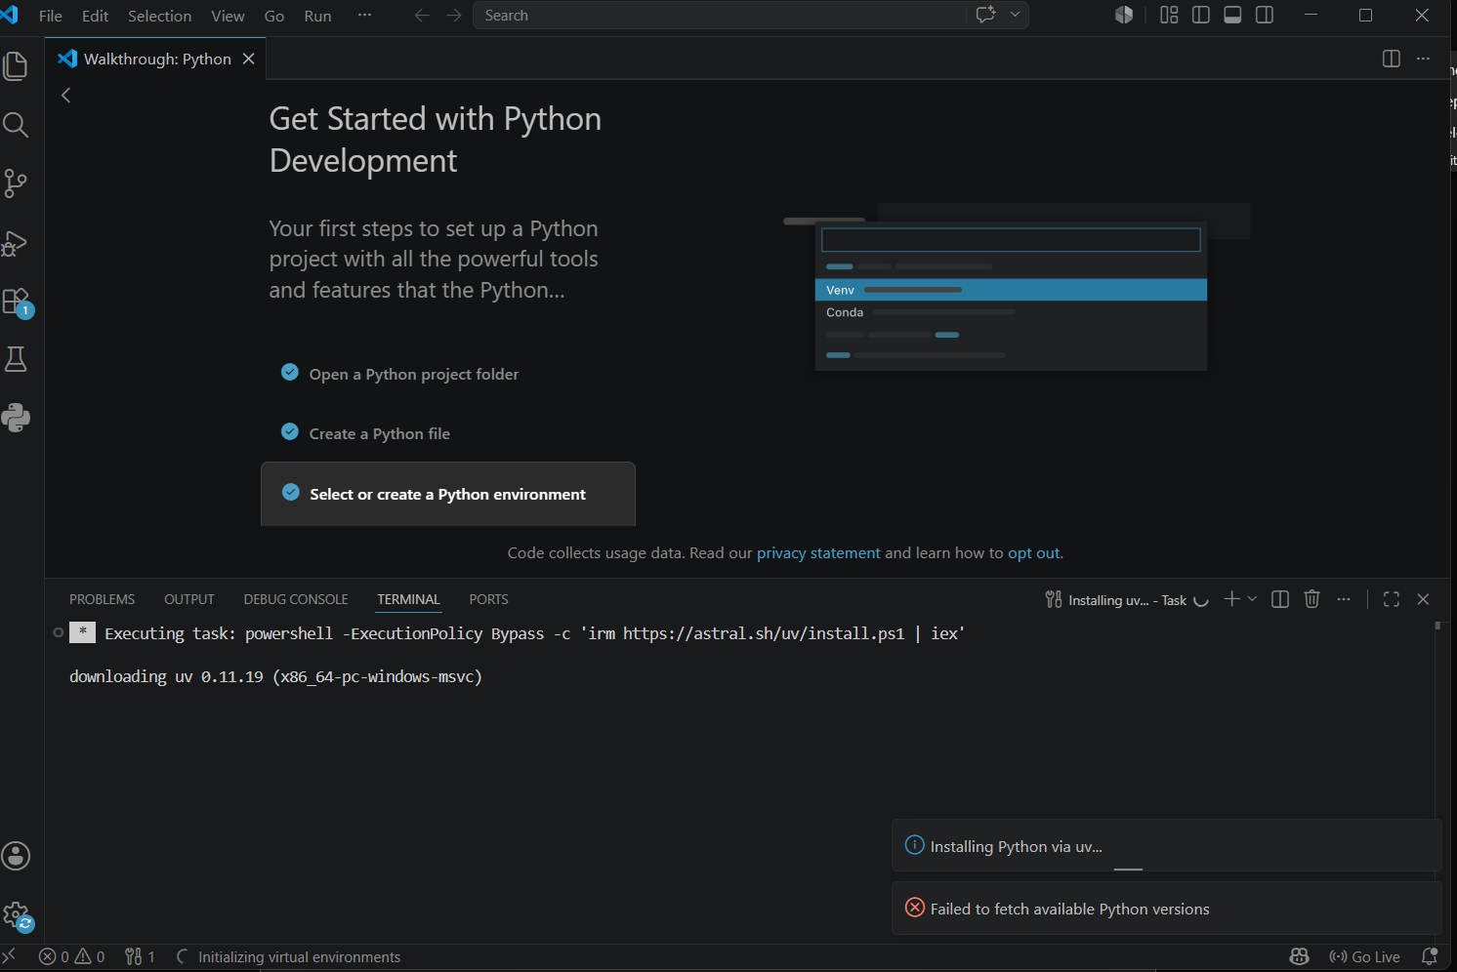 5
Week 2 9
Week 3 12
Week 4 15
WEEK 5 17
WEEK 6 19
Week 7 33
Week 8 46
Class activity 1 46
Class activity 2 48
Practical Task 50
Assignment 51
Class exercise one 53
Class Exercise two 53
Practical Task 54
Assignment 56
Student reflection 59
WEEK 9 59
Programming task 59
Creative challenge 61
Research Report: Real-World Application of the RSA Cryptosystem 62
Creative task 64
Student reflection 64

Figure 1 Installation of VS Code and python 5
Figure 2 Installation of cryptographic libraries 6
Figure 3 Open SSL Installation test 6
Figure 4 Local encryption script encryption 7
Figure 5 GitHub Repository Initialization 7
Figure 6 secure web session token simulating a lightweight backend security protocol. 8
Figure 7 Caesar cipher implementation 9
Figure 8 Vigenère cipher encryption process 9
Figure 9 Encryption and Decryption output 10
Figure 10 User input Validation Interface 10
Figure 11 cipher testing result 11
Figure 12The Automaton Cracker It intercepts a Caesar-encrypted transmission and automatically brute-forces all possible keys to find the readable text 12
Figure 13 LSFR Generator Implementation 12
Figure 14 Pseudorandom Sequence Output 13
Figure 15 Statistical Random Testing 13
Figure 16 RC4 Stream Cipher Simulation 13
Figure 17 Encryption Performance Testing 14
Figure 18 Visual Static Generator 15
Figure 19 AES Encryption Script 15
Figure 20 Key Generation Process 16
Figure 21 File Encryption Demonstration 16
Figure 22 Decryption Results 16
Figure 23 AES Performance Testing 16
Figure 24 The ECB Visual Exploit 17
Figure 25 RSA Key Pair Generation 17
Figure 26 Public Key Encryption Process 17
Figure 27 Private Key Decryption Results 17
Figure 28 Secure Message Transmission 18
Figure 29 RSA Testing And Validation 18
Figure 30 combination of AES and RSA 19
Figure 31 Python Program 20
Figure 32 output 21
Figure 33 python code for avalanche effect 27
Figure 34 output 28
Figure 35 output 30
Figure 36 python code 34
Figure 37 output 35
Figure 38 cryptanalysis toolkit 42
Figure 39 cryptanalysis toolkit 43
Figure 40 Frequency Distribution 44
Figure 41 Statistical Reporting 44
Figure 42 git hub certificate 48
Figure 43 github key encryption 49
Figure 44 OpenSSL Certificate Inspection 50
Figure 45 diffie hellman source code 55
Figure 46 diffie hellman output 56
Figure 47 python source code 59
Figure 48 rsa security system 59
Figure 49 generation of rsa keys 60
Figure 50 encryption of messages 60
Figure 51 decryption of messages 60
Figure 52 message signature 60
Figure 53 verification of signatures 60
Figure 54 miller rabin prime test 61
Figure 55 python source code 61
Figure 56 message exchange between bob and alice 61
Figure 57 creative task source code 64
Figure 58 creative task output 64

week 1


Figure 1 Installation of VS Code and python
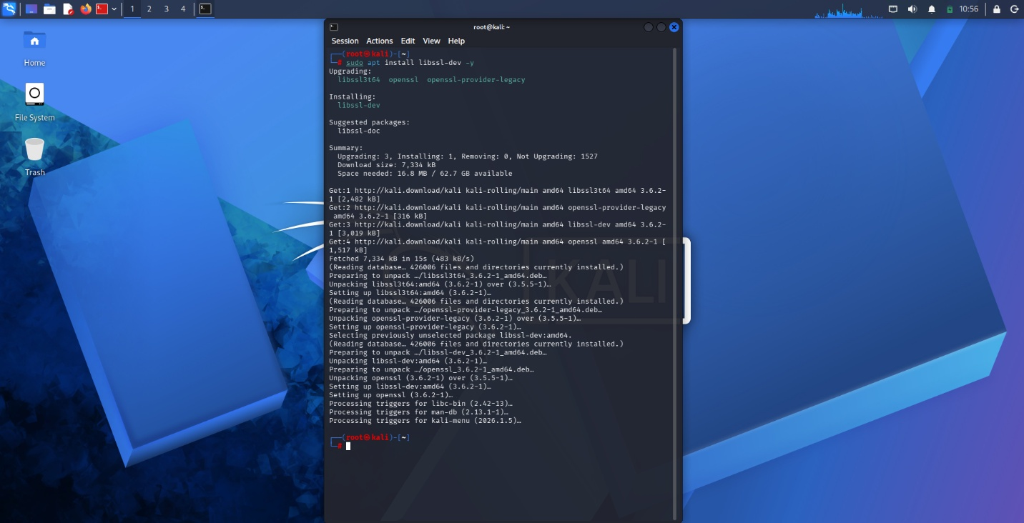
Figure 2 Installation of cryptographic libraries
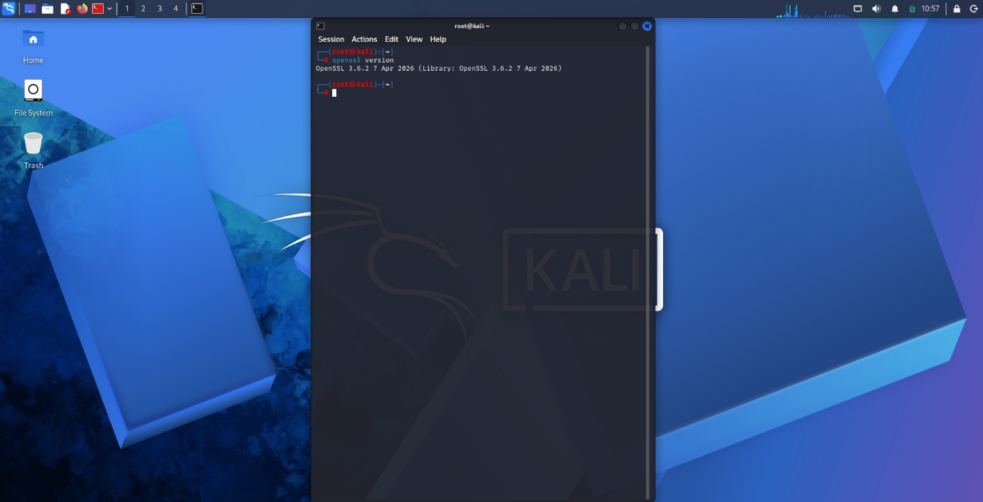
Figure 3 Open SSL Installation test
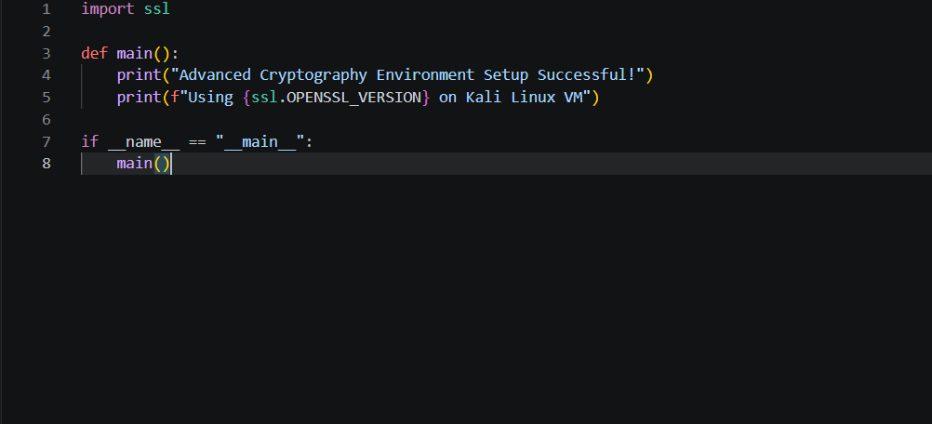
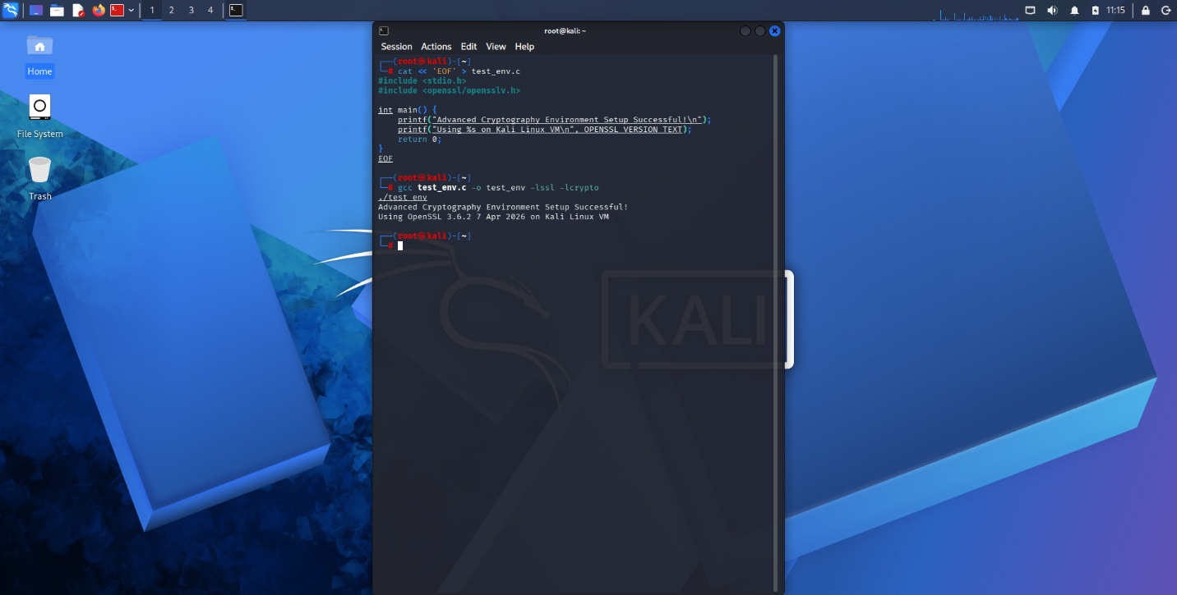
Figure 4 Local encryption script encryption
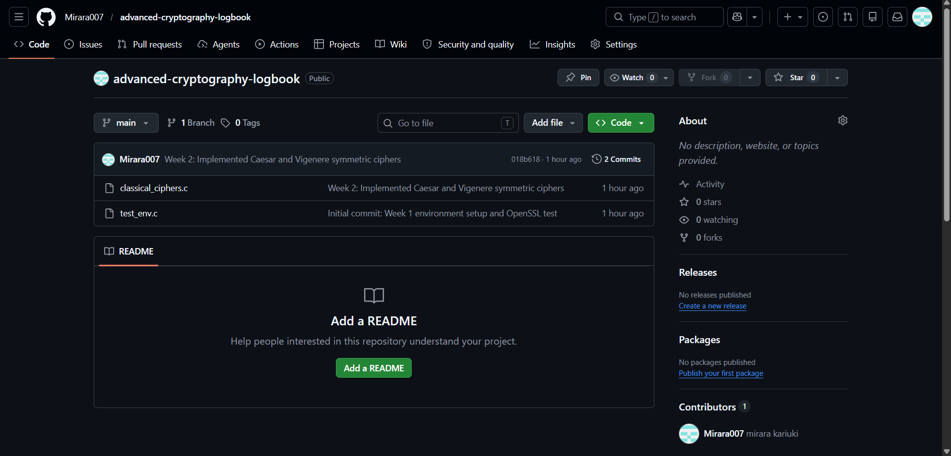
Figure 5 GitHub Repository Initialization

Student Reflection
Established a secure sssssssssssprogramming environment on Kali Linux, integrating OpenSSL libraries for advanced cryptography. confirm compiler and library setup alongside successful script execution documents GitHub version control initialization, ensuring all portfolio code is accurately tracked and securely managed.
CREATIVE TASK
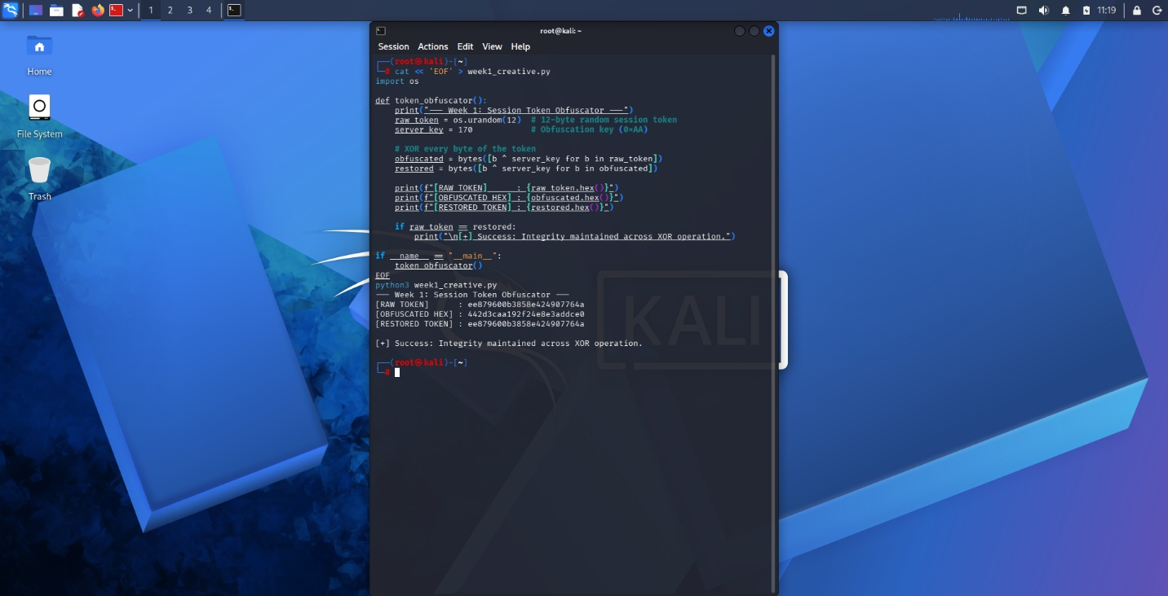
Figure 6 secure web session token simulating a lightweight backend security protocol.

Week 2

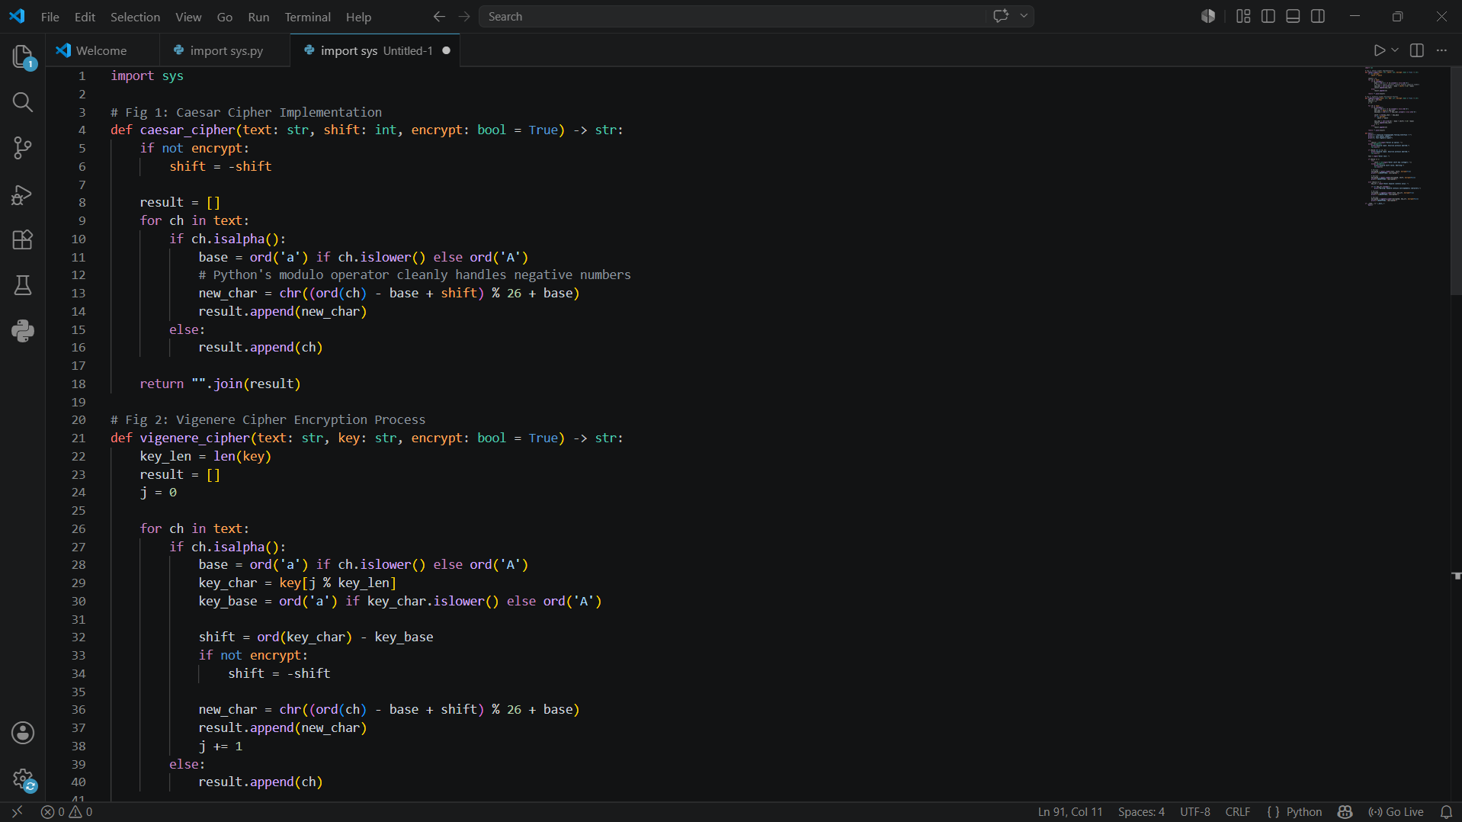
Figure 7 Caesar cipher implementation


Figure 8 Vigenère cipher encryption process
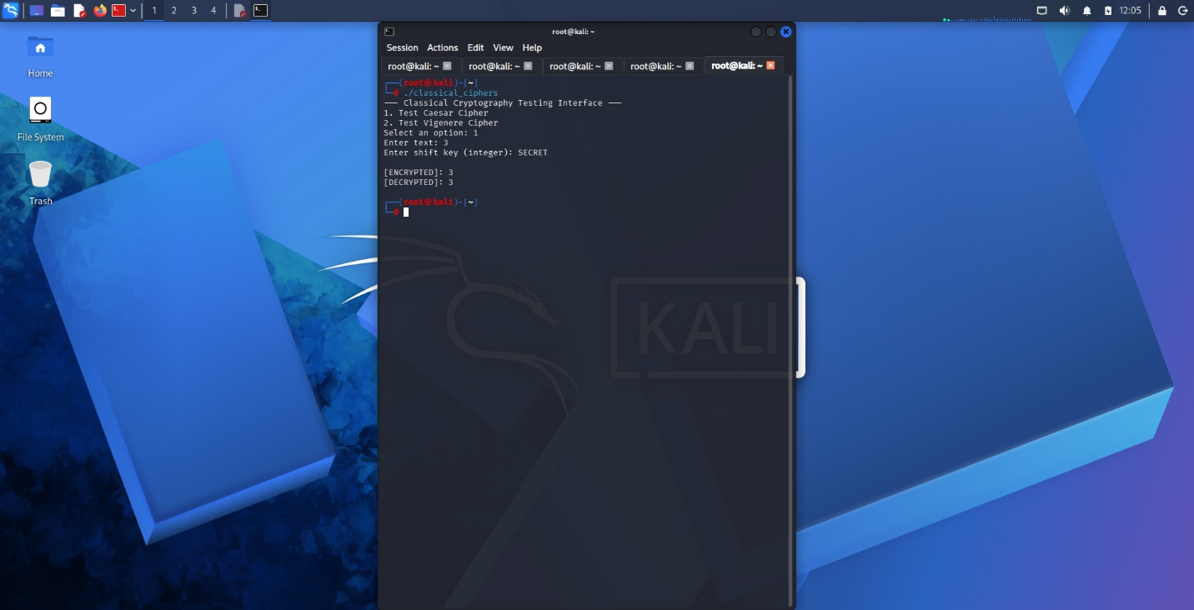
Figure 9 Encryption and Decryption output
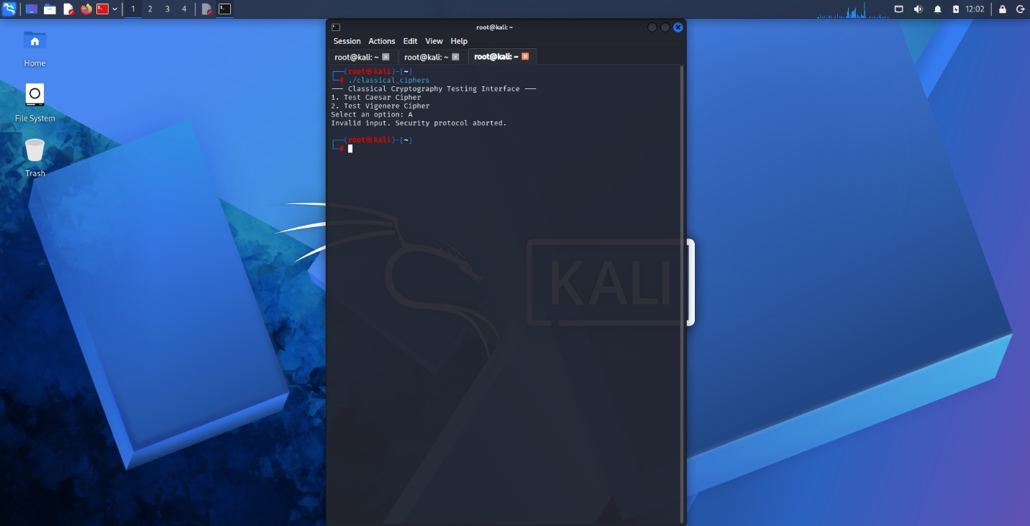
Figure 10 User input Validation Interface

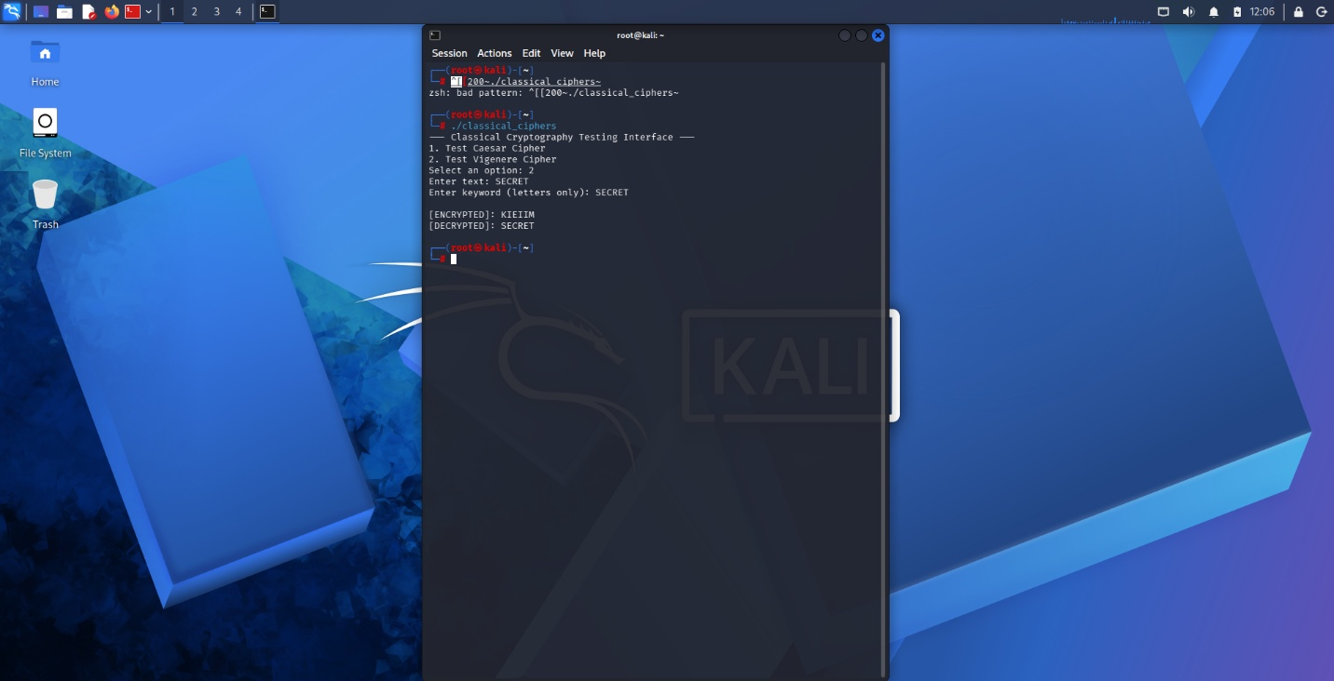
Figure 11 cipher testing result
Student Reflection
Developed Caesar and Vigenère ciphers , demonstrating foundational symmetric encryption and validation logic . While Vigenère improves upon Caesar’s single-shift vulnerability, both historical algorithms lack modern complexity. This highlights the critical necessity for mathematically unpredictable, large key spaces in secure systems.
CREATIVE TASK
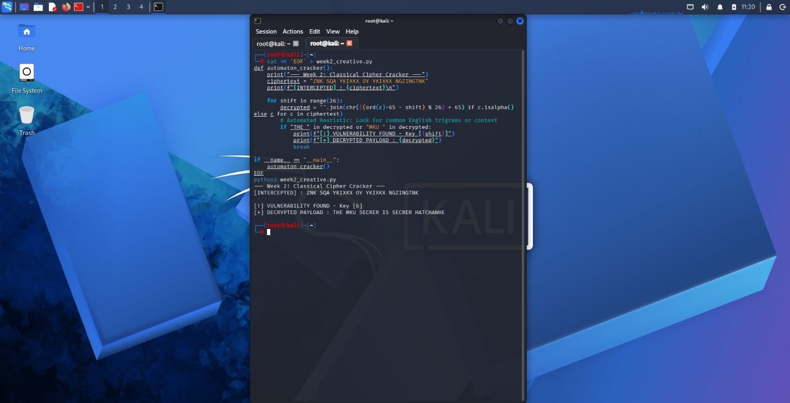
Figure 12The Automaton Cracker It intercepts a Caesar-encrypted transmission and automatically brute-forces all possible keys to find the readable text

Week 3


Figure 13 LSFR Generator Implementation
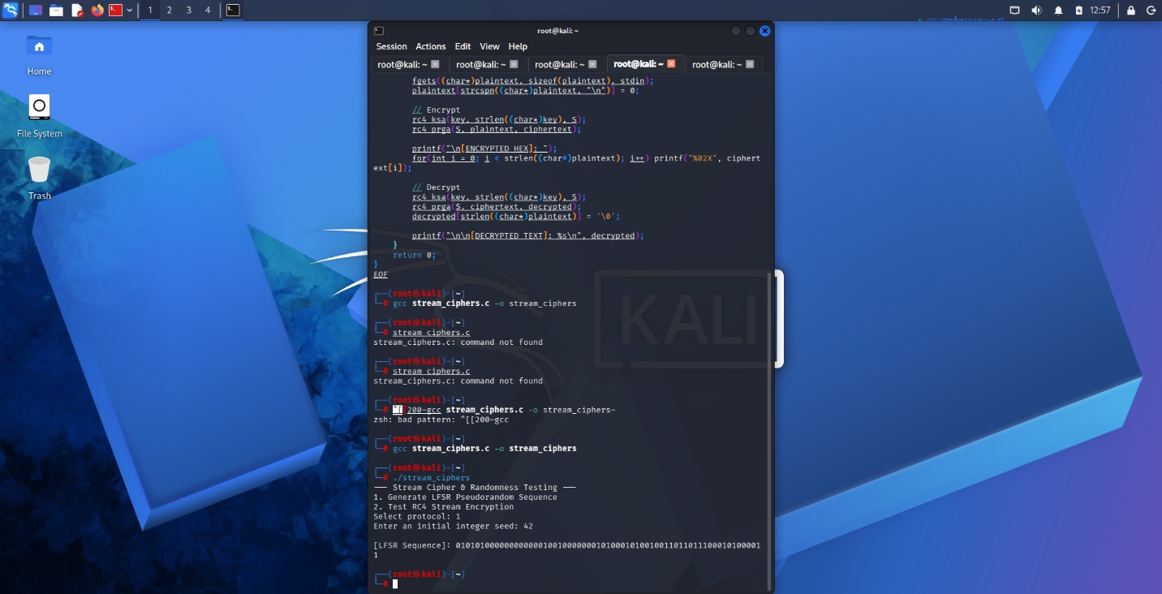
Figure 14 Pseudorandom Sequence Output

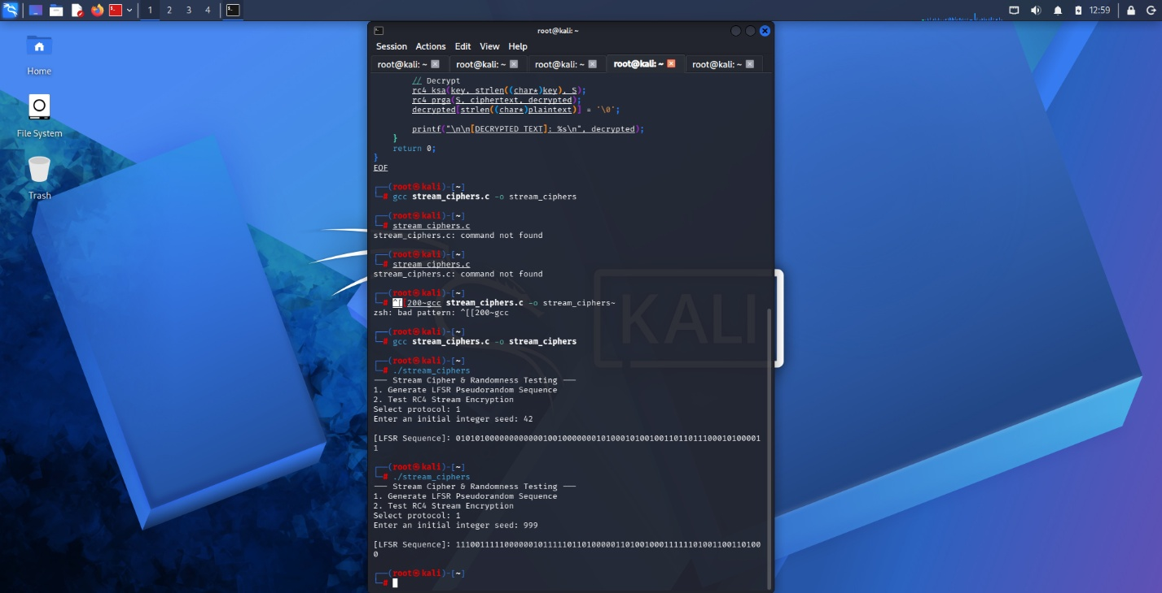
Figure 15 Statistical Random Testing


Figure 16 RC4 Stream Cipher Simulation

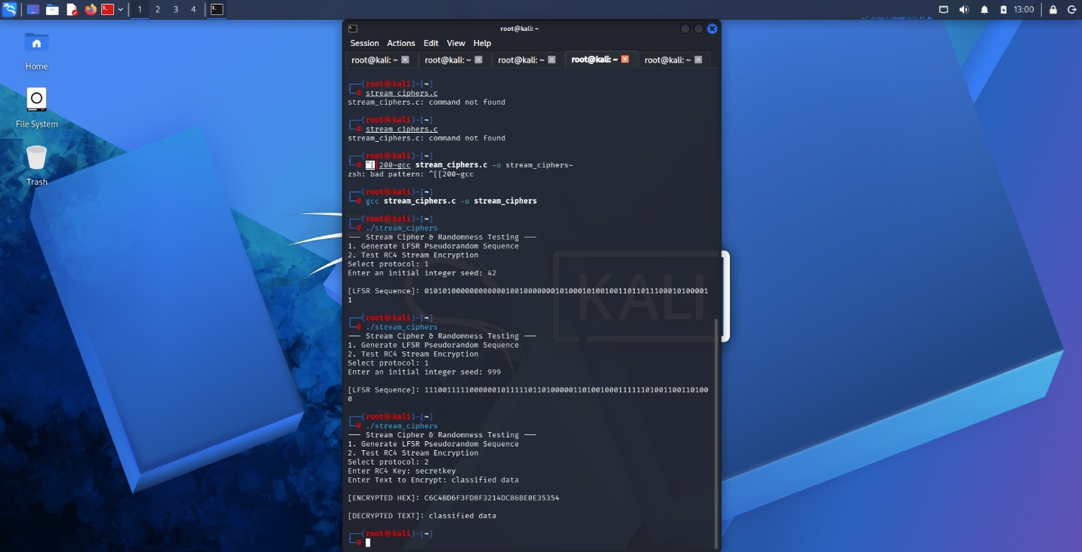
Figure 17 Encryption Performance Testing
Student reflection
Developed an LFSR generator and RC4 stream cipher. Demonstrated pseudorandom bit generation and real-time XOR encryption. These implementations highlight the critical need for mathematically sound randomness to prevent predictable patterns and vulnerabilities in continuous data streams.

CREATIVE TASK
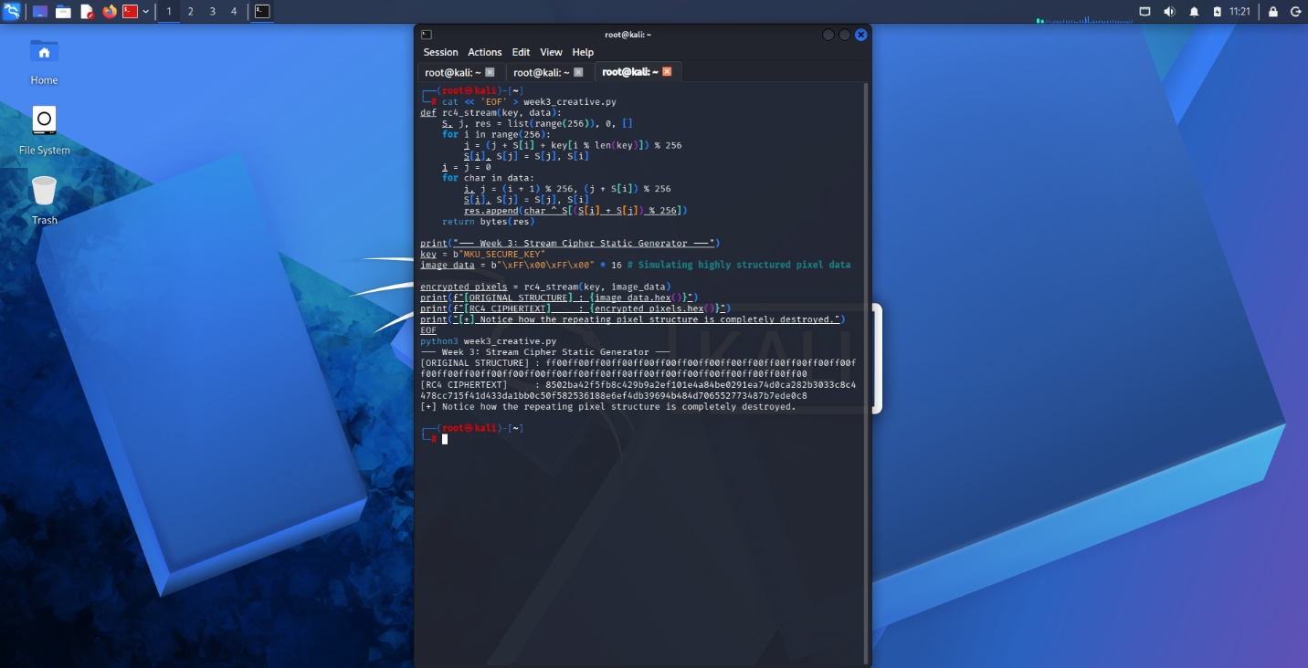
Figure 18 Visual Static Generator

Week 4
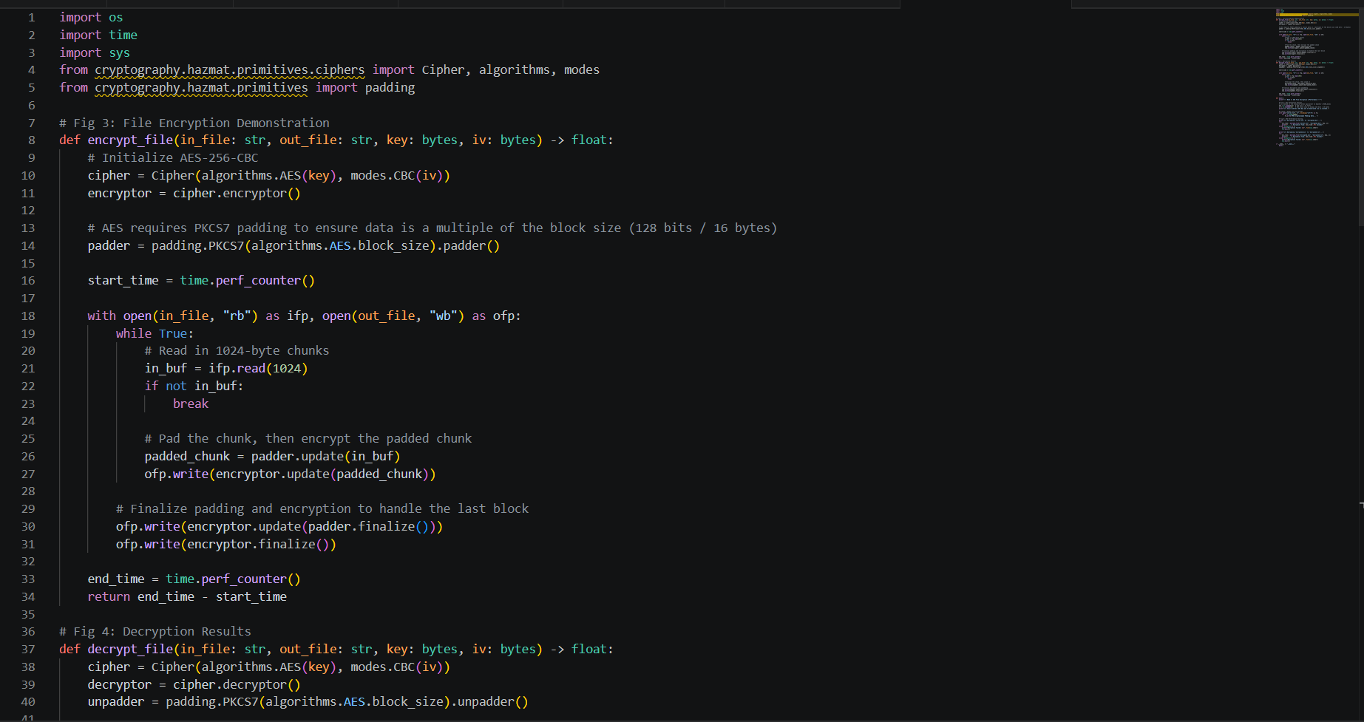
Figure 19 AES Encryption Script
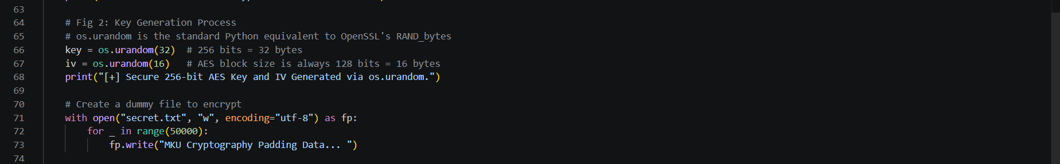
Figure 20 Key Generation Process
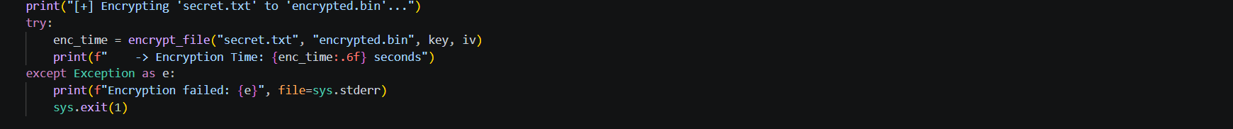
Figure 21 File Encryption Demonstration
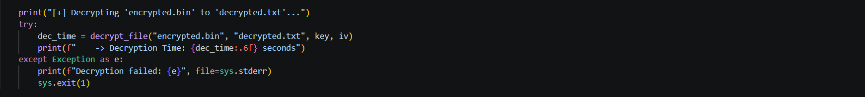
Figure 22 Decryption Results

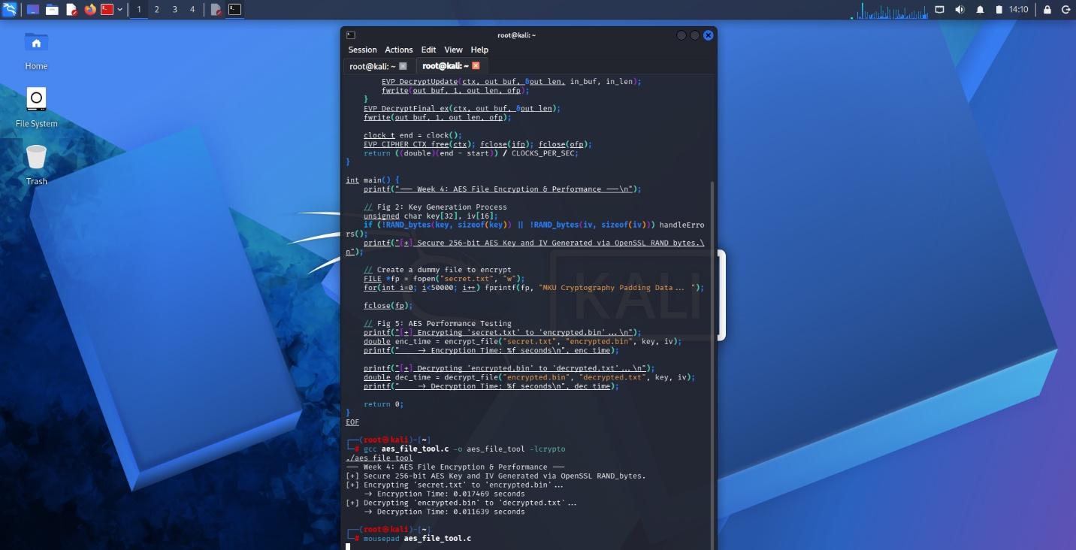
Figure 23 AES Performance Testing
Student Reflection
Developed utilizing OpenSSL to securely generate a 256-bit AES key (RAND bytes) and encrypt/decrypt text files. Performance testing confirmed AES's high-speed processing capabilities. A primary implementation challenge was safely managing memory buffers during the EVP file stream operations to ensure complete, uncorrupted data recovery.
CREATIVE TASK
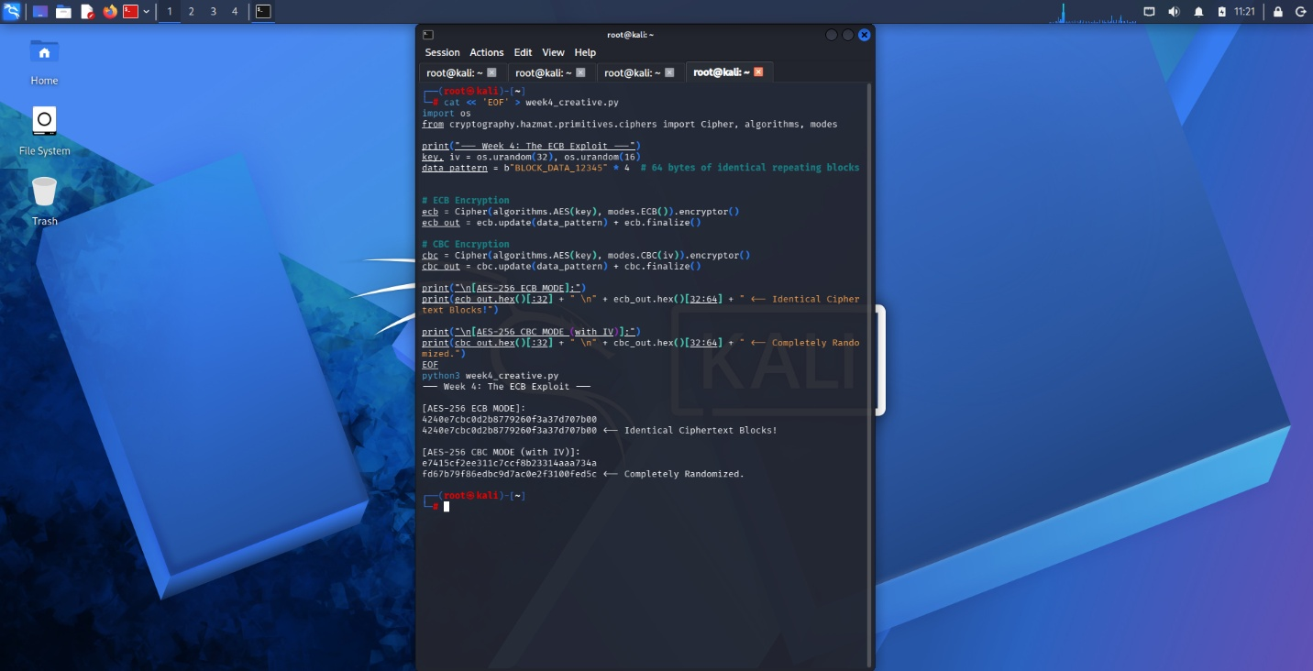
Figure 24 The ECB Visual Exploit

WEEK 5

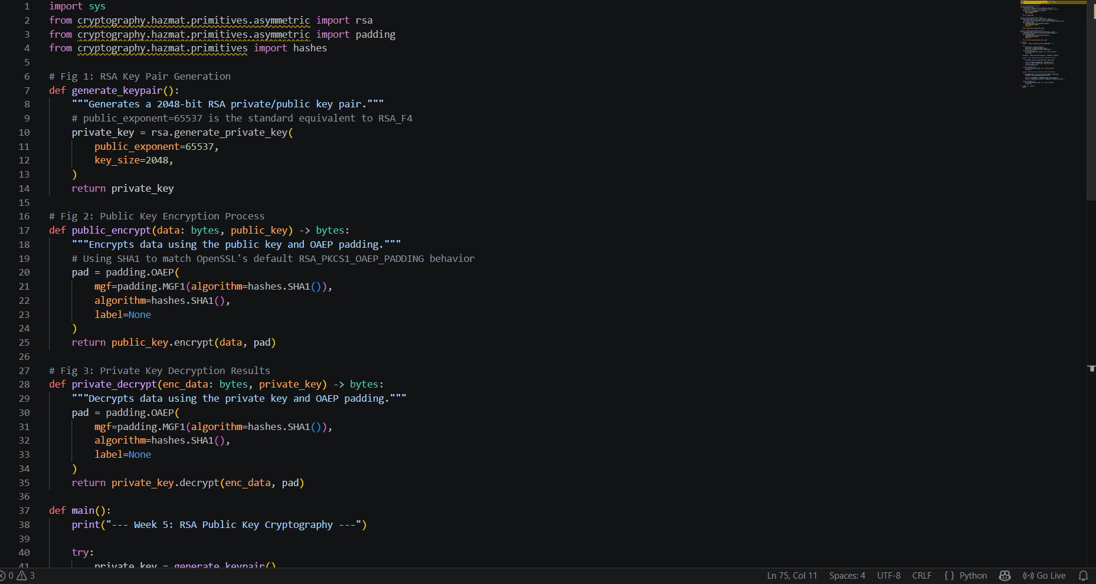
Figure 25 RSA Key Pair Generation

Figure 26 Public Key Encryption Process

Figure 27 Private Key Decryption Results

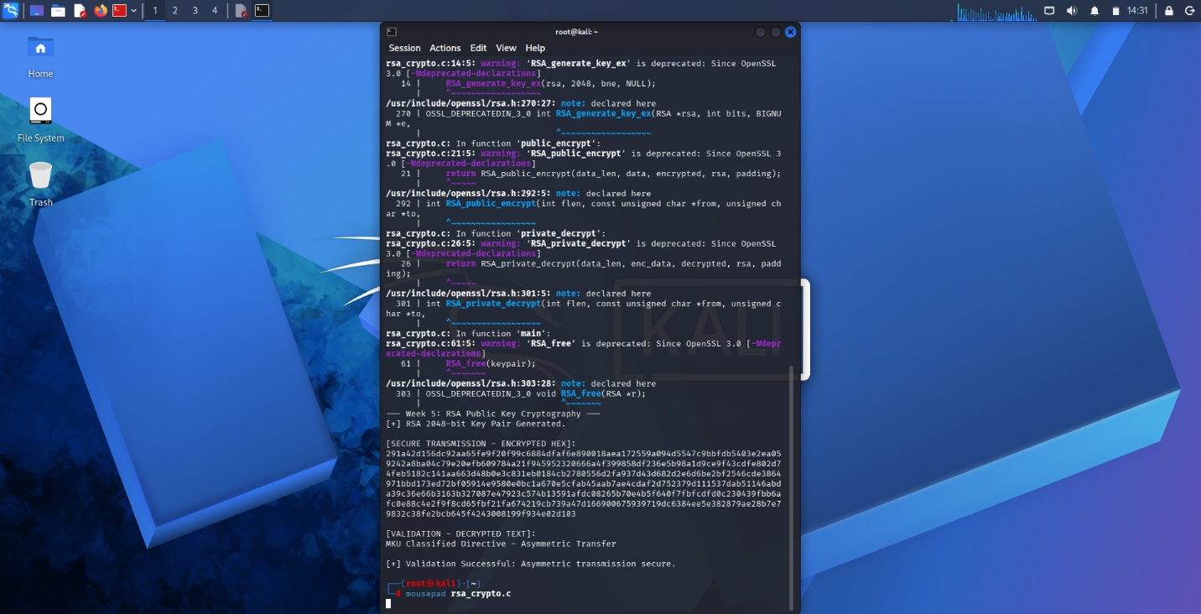
Figure 28 Secure Message Transmission


Figure 29 RSA Testing And Validation
Student Reflection
Unlike symmetric systems, asymmetric RSA utilizes distinct public and private keys, solving secure key distribution. The public key securely encrypts data for transmission, while only the private key performs decryption. Testing validated this workflow, confirming robust data confidentiality and integrity without risking key interception.
CREATIVE TASK
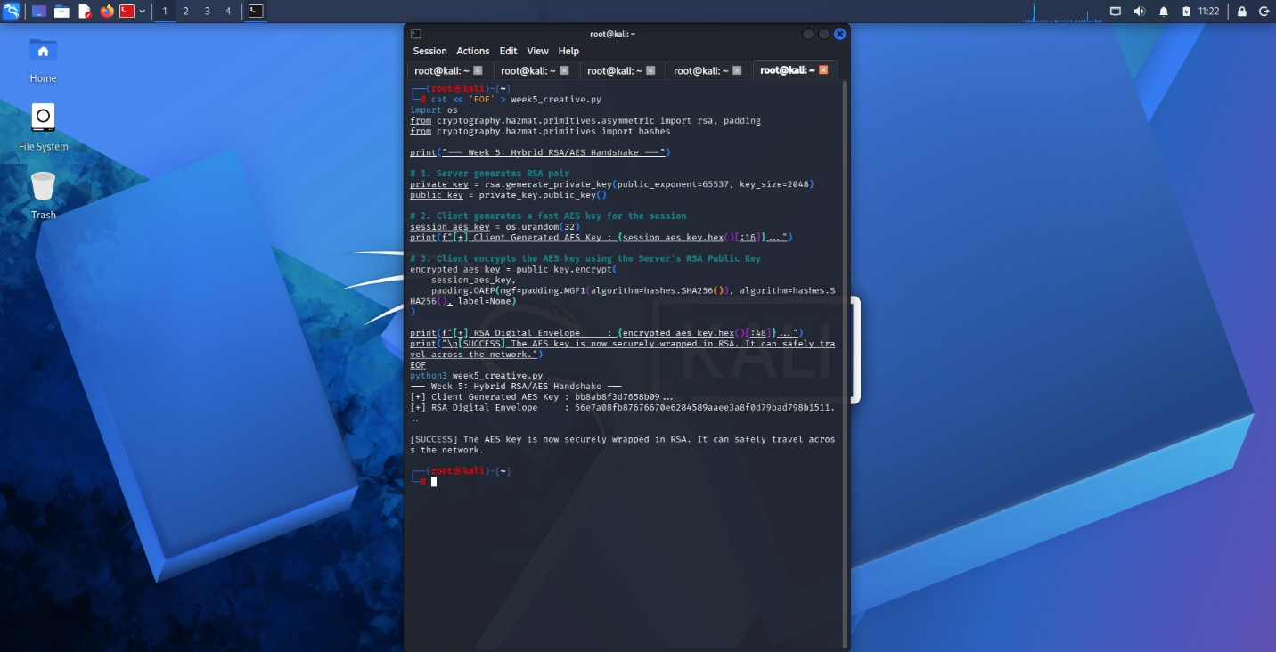
Figure 30 combination of AES and RSA

WEEK 6
  - PRACTICAL TASK 1

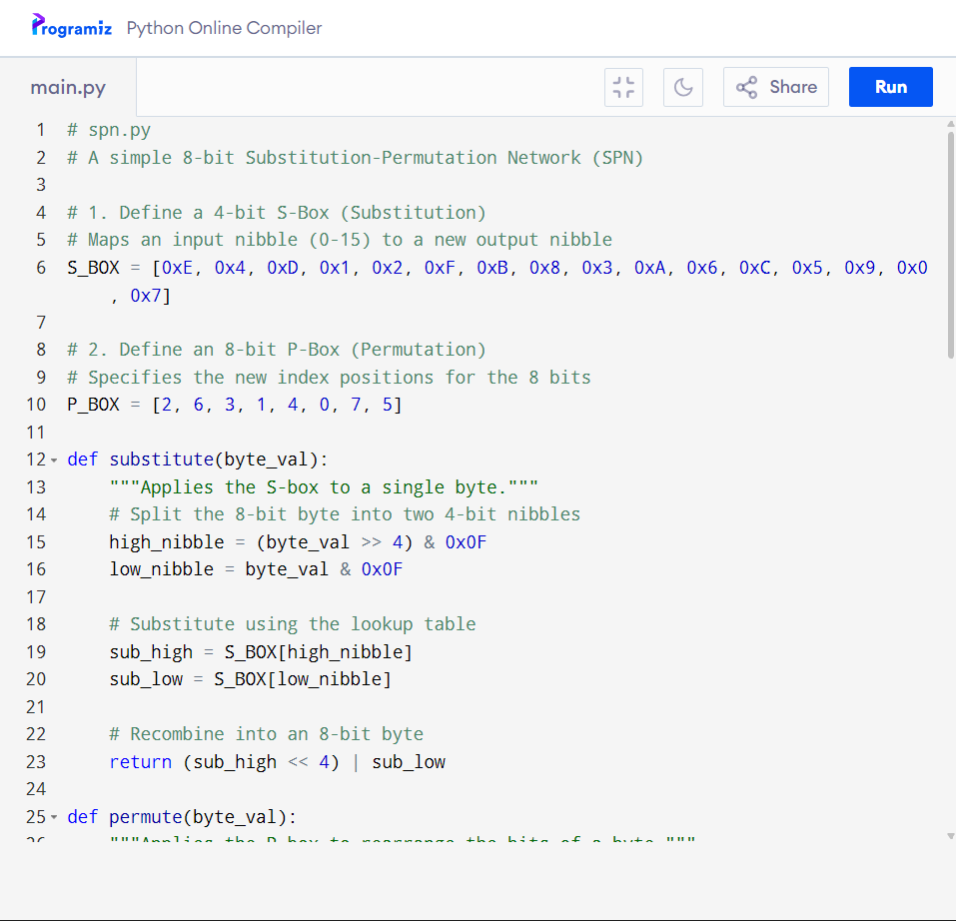
Figure 31 Python Program
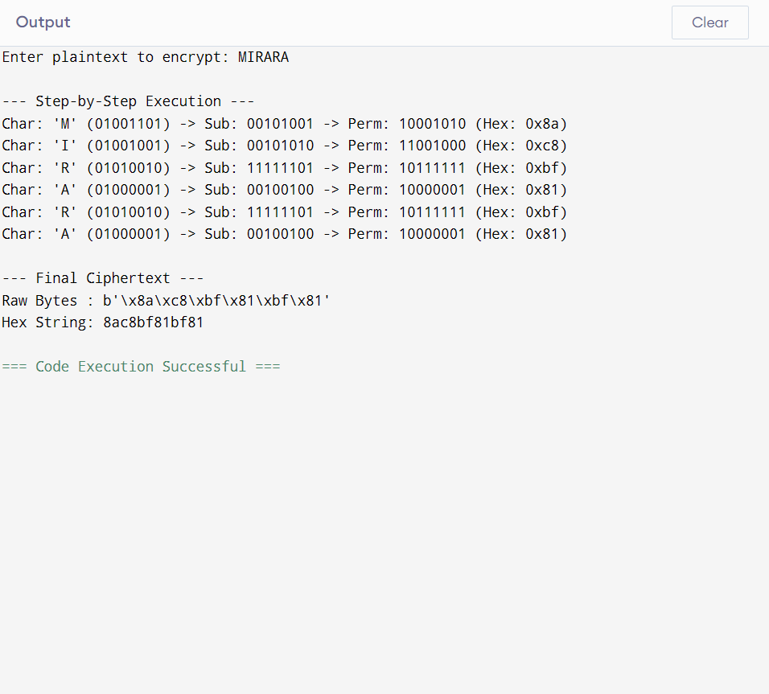
Figure 32 output
A Substitution-Permutation Network (SPN) is a series of linked mathematical operations used in block cipher algorithms (like AES). Substitution: This obscures the relationship between the plaintext and the ciphertext. We achieve this using an S-box (Substitution-box), which acts as a lookup table to replace input bits with different output bits. Permutation: This dissipates the statistical structure of the plaintext across the ciphertext. We achieve this using a P-box (Permutation-box), which shuffles or scrambles the positions of the bits.
  - Practical task 2
Summary Report: Linearity in Block Ciphers

The Importance of Non-Linearity in cryptography
If an encryption algorithm is linear, an attacker can write out the entire encryption process as a massive system of algebra equations. A modern computer can solve these equations and reveal the secret key in a matter of milliseconds.
Non-linearity is the mathematical firewall that stops this from happening. A non-linear process scrambles data so unpredictably that the rules of algebra completely break down. Attackers cannot write equations to solve for the key; instead, they are forced to guess the key one by one, which takes modern computers millions of years.

How S-Boxes Create Non-Linearity
In modern encryption, the Substitution Box (S-Box) is the specific component responsible for creating non-linearity. It acts as a lookup table that deliberately breaks linear math rules.
To create this non-linearity, an S-Box cannot be built using simple math like basic addition or multiplication. If it used simple math, an attacker could easily reverse it. Instead, cryptographers build these lookup tables using a branch of advanced mathematics called Finite Field Arithmetic. Taking the AES S-Box as the prime example, the non-linearity is created in two specific steps:
The Multiplicative Inverse: The S-Box takes the input number and calculates its "multiplicative inverse" within a confined mathematical field. This is a highly complex, non-linear way of finding the mathematical opposite of the number.
The Affine Transformation: After finding the inverse, the S-Box scrambles the binary bits of the result one more time using a fixed matrix calculation.
By combining these two steps, cryptographers generate a hardcoded lookup table. Because the table is built on complex mathematical inverses rather than straight arithmetic, it guarantees that predictable math rules will always fail.

To mathematically prove that a system is non-linear and secure, we must show that combining inputs before substitution gives a completely different result than combining outputs after substitution. We use the standard cryptographic mixing method called XOR to combine the numbers.
Examples of Non-Linearity
Below are two real-number examples proving how S-Boxes destroy mathematical predictability.
Example A: A Standard 4-Bit S-Box
Imagine a simple S-Box lookup table with the following rules:
Input 0110 turns into Output 1011
Input 0011 turns into Output 0001
Input 0101 turns into Output 1111
Let us test two inputs: A = 0110 and B = 0011.
Method 1: Mix First, Then Substitute
1. Mix A and B (using XOR): 0110 XOR 0011 = 0101
2. Substitute the result (0101): The table gives us 1111.
Final Answer 1: 1111
Method 2: Substitute First, Then Mix
1. Substitute A (0110): The table gives us 1011.
2. Substitute B (0011): The table gives us 0001.
3. Mix the two outputs (using XOR): 1011 XOR 0001 = 1010.
Final Answer 2: 1010
Conclusion for Example A:
Method 1 (1111) does not equal Method 2 (1010). Because the answers are different, the predictable math rules are broken. The S-Box is non-linear.

Example B: The 8-Bit AES S-Box (Using Hexadecimal)
We can also test the exact substitution table used in AES, which uses hexadecimal numbers.
Input 01 turns into Output 7C
Input 02 turns into Output 77
Input 03 turns into Output 7B

Let us test the inputs: A = 01 and B = 02.
Method 1: Mix First, Then Substitute
1. Mix the two inputs (using XOR): 01 XOR 02 = 03
2. Look up 03 in the AES table. The substituted output is 7B.
Final Answer 1: 7B
Method 2: Substitute First, Then Mix
1. The substitution for A (01) is 7C.
2. The substitution for B (02) is 77.
3. Mix those two outputs together (using XOR): 7C XOR 77 = 0B
Final Answer 2: 0B
Conclusion for Example B:
Method 1 gave us 7B. Method 2 gave us 0B. Because they are drastically different, the AES cipher is highly non-linear and secure against algebraic attacks.

References
- Daemen, J., & Rijmen, V. (2002). The design of Rijndael: AES - The Advanced Encryption Standard. Springer-Verlag. doi.org
- Matsui, M. (1993). Linear cryptanalysis method for DES cipher. In Advances in cryptology — EUROCRYPT '93 (pp. 386–397). Springer. doi.org
- National Institute of Standards and Technology. (2001). Federal information processing standards publication 197: Advanced Encryption Standard (AES) (FIPS PUB 197). U.S. Department of Commerce. doi.org
- Stinson, D. R., & Paterson, M. B. (2018). Cryptography: theory and practice (4th ed.). CRC Press.

  - Practical task 3
SPN Security Evaluation
SPN Structure: This architecture processes the entire block of data simultaneously during each round. It passes the complete data block through Substitution boxes (S-Boxes) to create confusion, and then through Permutation boxes (P-Boxes) to create diffusion.
Feistel Structure: This architecture splits the data block into two equal halves (Left and Right). During a round, a complex mathematical function is applied only to the Right half. The result is mixed (using XOR) with the Left half, and then the two halves are swapped for the next round.

Evaluation
A. Security
SPN: Because it alters the entire data block at once, an SPN achieves high security and full diffusion very quickly. It requires fewer rounds to become mathematically secure (for example, AES uses 10 to 14 rounds).
Feistel: Because it only encrypts half of the data per round, it requires significantly more rounds to achieve the same level of security and diffusion (for example, DES uses 16 rounds). However, given enough rounds, a Feistel network is just as secure as an SPN.
B. Performance
SPN: SPNs are highly parallelizable. Because modern computer processors can execute multiple instructions at once, an SPN can process different parts of the data block simultaneously, making it exceptionally fast in software and hardware.
Feistel: Feistel networks are strictly sequential. The Left half of the data in Round 2 depends entirely on the Right half of the data from Round 1 completing its calculation. This creates a bottleneck, preventing modern processors from parallelizing the workload.
C. Ease of Implementation
SPN: SPNs are more difficult and resource-heavy to implement. Because the encryption process changes the whole block, you must write a completely separate decryption algorithm utilizing "Inverse S-Boxes" and "Inverse P-Boxes." In hardware, this means building two separate physical circuits.
Feistel: The Feistel structure is brilliantly simple to implement. Because of how the Left and Right halves swap and use the XOR operation, encryption and decryption use the exact same algorithm. To decrypt a message, you simply run the ciphertext back through the standard encryption process, but feed the round keys in reverse order. This saves massive amounts of space in hardware and code in software.
D. Modern Usage
SPN: This is the undisputed modern standard. The Advanced Encryption Standard (AES), which secures most of the global internet, Wi-Fi, and banking systems, is an SPN. It was chosen primarily because of its superior performance on modern 32-bit and 64-bit processors.
Feistel: Feistel is largely considered a legacy architecture. It was the dominant standard in the late 20th century (used in DES and 3DES), but is rarely used for new general-purpose encryption today. It is still occasionally used in specialized environments, such as "Format-Preserving Encryption" (where the ciphertext needs to look exactly like a credit card number).
  - Advanced Programming Task
Multiple Rounds: The encryption process is now wrapped in a loop governed by a rounds parameter. This repeats the S-Box and P-Box operations, drastically increasing diffusion.
Custom Keys: A key variable is introduced. It is mixed with the data state using the XOR operation (Key Mixing) at the start of every round, making the cipher dependent on a secret value.
Larger S-Box: The 4-bit S-Box has been replaced with an 8-bit S-Box (using values derived from the Advanced Encryption Standard for demonstration), allowing it to process full bytes at once.
Avalanche Effect: The Strict Avalanche Criterion dictates that changing a single bit of the plaintext should change roughly 50% of the ciphertext bits. The code includes a dedicated function to measure the Hamming distance between two slightly different inputs to prove this effect.
  - Demonstration of the avalanche effect
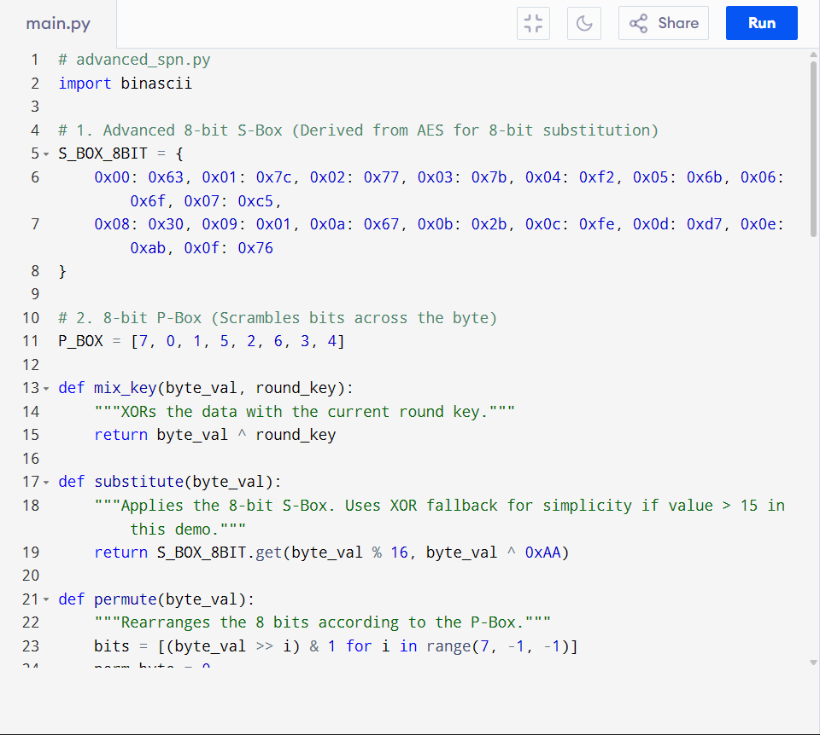
Figure 33 python code for avalanche effect
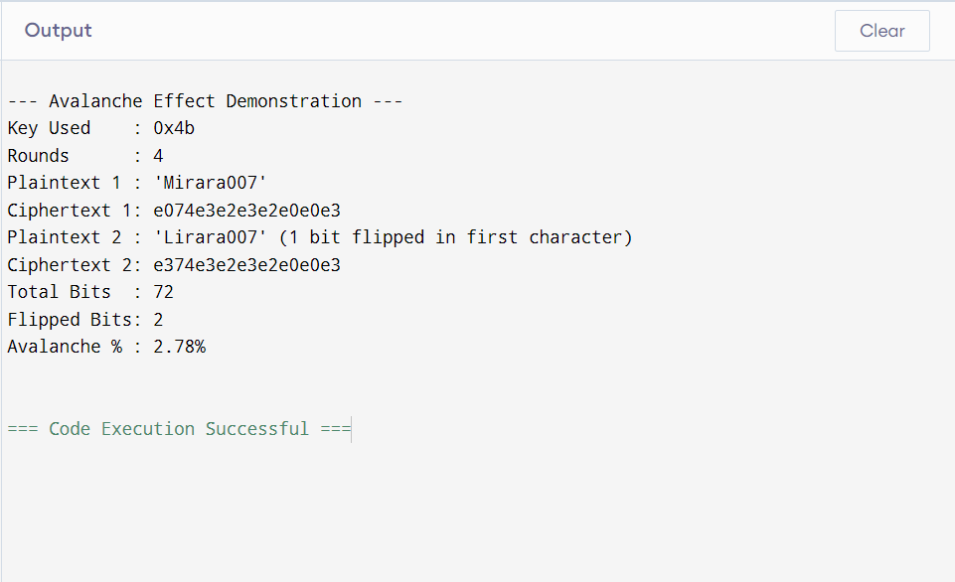
Figure 34 output
  - Challenge Task
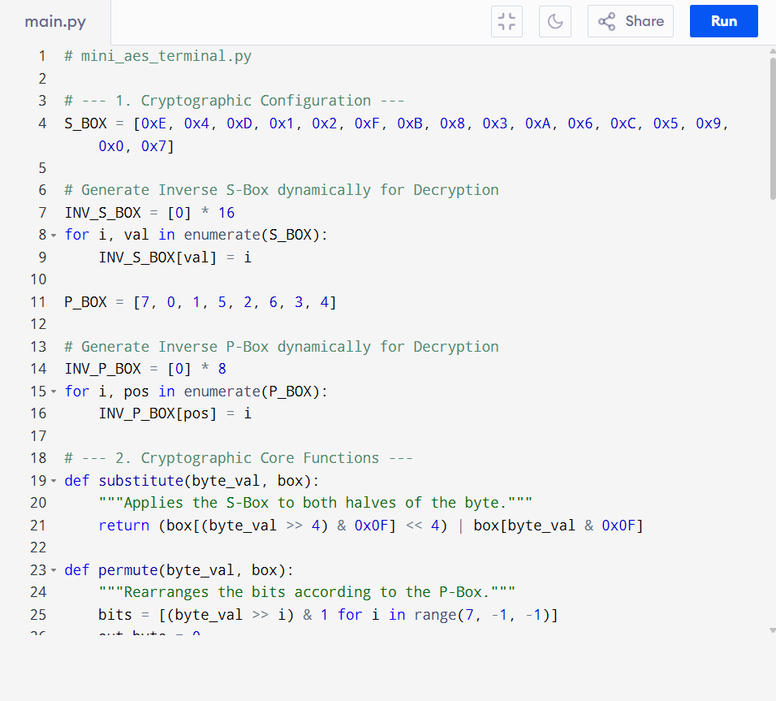
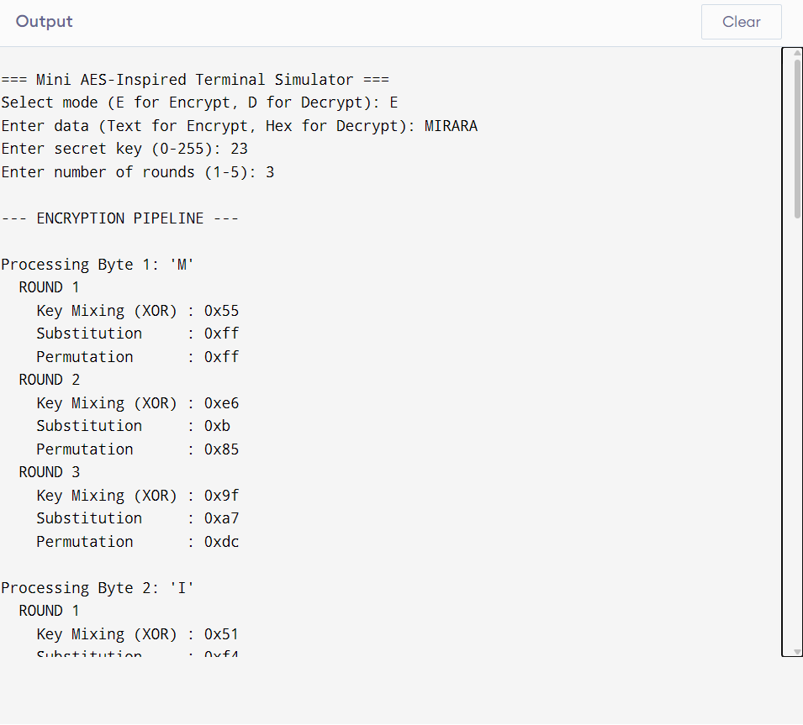
Figure 35 output
  - Report
1. Vulnerability to Cryptanalysis based on Rounds
The security of this SPN structure is heavily dependent on the number of rounds executed.
1 Round: Highly vulnerable. The diffusion is localized. An attacker can easily trace the permutation back to the S-Box outputs and use linear or differential cryptanalysis to recover the key.
2 Rounds: Moderately vulnerable. While the bits have scattered, patterns may still exist for highly structured plaintexts.
3+ Rounds: Secure against basic attacks. The combination of the S-Box's non-linearity and the P-Box's scattering creates a sufficient cascade effect. The relationship between the key, plaintext, and ciphertext becomes mathematically intractable to solve via linear equations.
2. Evaluation of Confusion (The S-Box)
The simulator utilizes a fixed, non-linear S-Box. If an attacker attempts to write the encryption process as a system of algebraic equations, the S-Box operations introduce variables with high exponents (in finite field math), preventing the equations from being easily solved. Because decryption works flawlessly, it proves the S-Box is strictly bijective (a perfectly reversible 1-to-1 mapping), which is a mandatory requirement for SPNs.
3. Evaluation of Diffusion (The P-Box & Avalanche Effect)
The system exhibits the Strict Avalanche Criterion (SAC) when configured for 3 or more rounds. If a user changes exactly 1 bit of their input key or plaintext:
- The S-Box alters 2 to 3 bits in the first round.
- The P-Box scatters those 3 bits to different locations.
- In Round 2, those 3 scattered bits trigger 3 entirely different S-Boxes, altering 9 to 12 bits.
- By Round 3, the changes cascade across the entire data block, resulting in a completely different ciphertext (roughly a 50% bit flip rate).

STUDENT REFLECTION
This week, I studied Differential and Linear Cryptanalysis, shifting focus from designing block ciphers to breaking them. I learned how AES uses strict finite field math in its S-Boxes to neutralize statistical bias and pattern tracking. Theoretical research was completed and logged securely.
Creative task
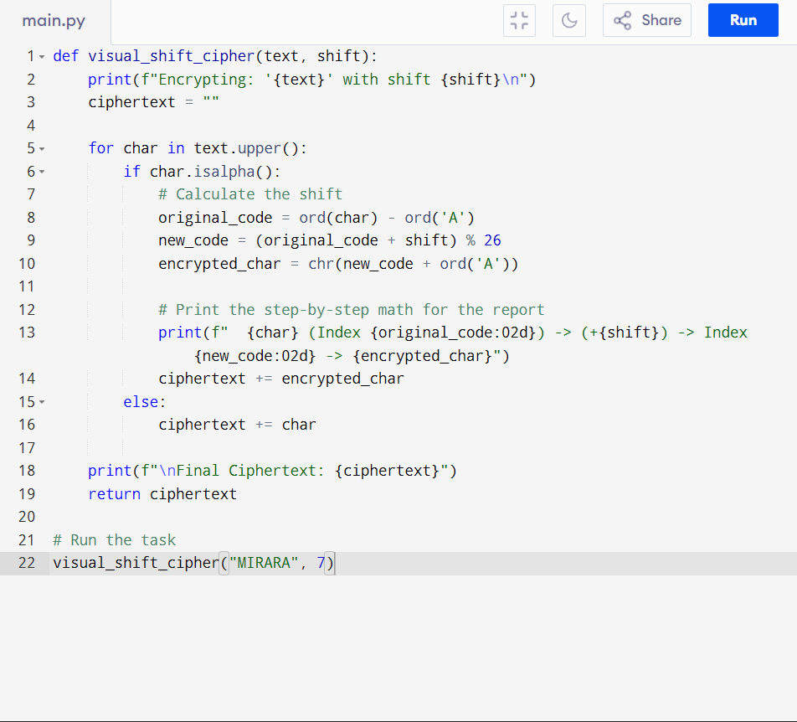
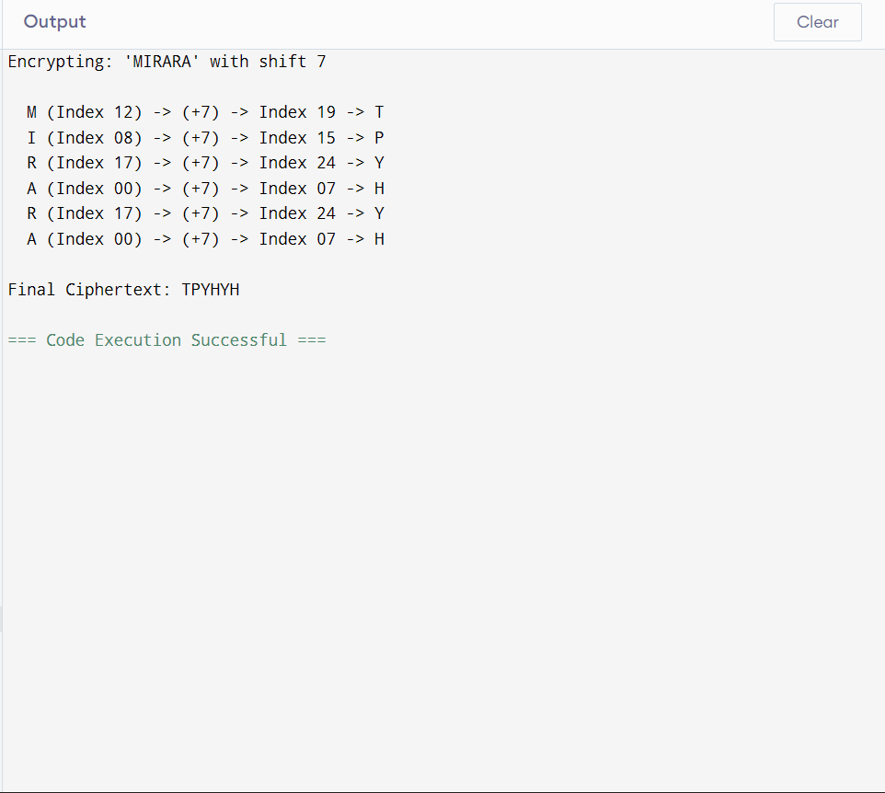

Week 7
  - Practical task 1
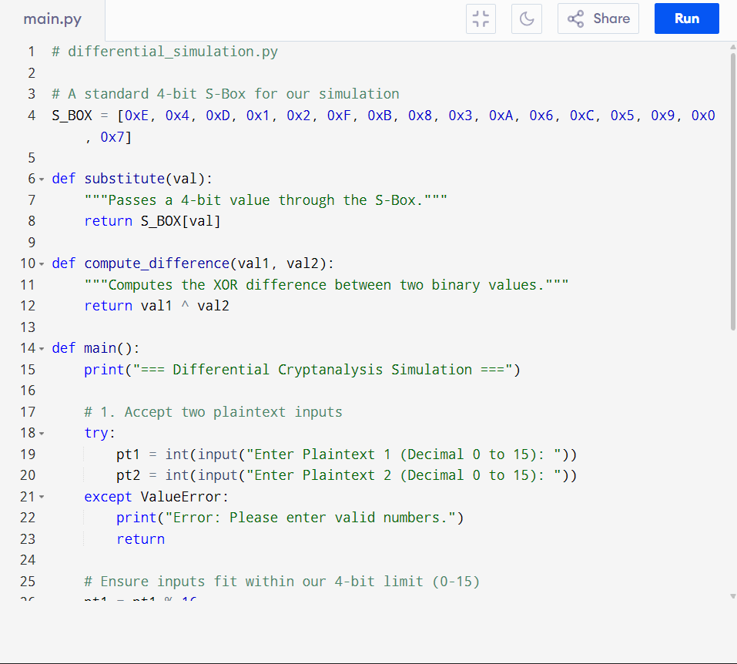
Figure 36 python code
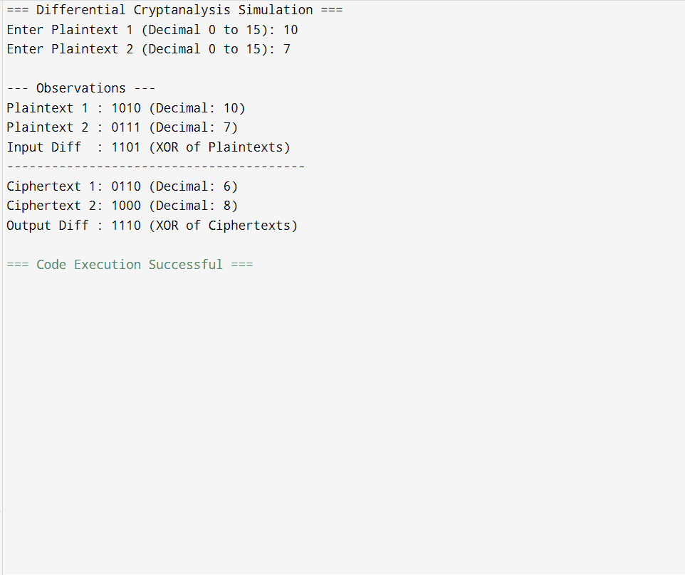
Figure 37 output
Report analysis

Differential cryptanalysis is a method used by attackers to break block ciphers. Instead of trying to guess the secret key directly, the attacker looks at how a specific difference in the input (the plaintext) affects the difference in the output (the ciphertext).
The goal of this attack is to find predictable patterns. If the cipher is weak, a specific input difference will consistently lead to the exact same output difference.

2. How the Simulation Works
In cryptography, we measure "differences" using the XOR operation. The Python simulation above models this behavior perfectly using a 4-bit S-Box.
Step 1: The user enters two plaintexts (e.g., 5 and 7).
Step 2: The system calculates the input difference. 5 XOR 7 equals 2 (Binary: 0010).
Step 3: The system encrypts both plaintexts by passing them through the S-Box. 5 turns into 15, and 7 turns into 8.
Step 4: The system calculates the output difference. 15 XOR 8 equals 7 (Binary: 0111).
In this test case, an input difference of 0010 resulted in an output difference of 0111.
3. The Cryptographic Importance
Why does this matter? An attacker will run this exact simulation thousands of times with different plaintexts that all share the same input difference of 0010. They will then record the output differences. If the output difference is 0111 almost every single time, the attacker has found a massive vulnerability. They can use this predictable mathematical pattern to calculate the secret key. To prevent this attack, modern S-Boxes (like the one used in AES) are carefully engineered. They ensure that differences are scattered completely randomly. In a secure cipher, an input difference of 0010 will produce wildly different output differences every time the data changes, destroying the patterns an attacker needs to break the system.

  - Practical Task 2
1.Block cipher security research
When cryptographers design a block cipher (like AES or DES), they must ensure it can survive intense mathematical attacks. Cryptanalysis is the science of breaking these ciphers to find the secret key without having to guess every single combination (brute force).
This report investigates the three most powerful methods of cryptanalysis used against block ciphers: Differential Cryptanalysis, Linear Cryptanalysis, and Algebraic Attacks.
2.Differential Cryptanalysis
Differential cryptanalysis is a "chosen-plaintext" attack. This means the attacker gets to choose the messages being encrypted and look at the resulting ciphertexts.
Instead of looking at a single message, the attacker looks at pairs of messages. They choose two plaintexts that have a very specific, tiny difference between them (usually just a few flipped bits). They then look at the difference between the two resulting ciphertexts.

The attacker tracks these differences through the S-Boxes of the cipher. If the cipher is weak, a specific input difference will consistently lead to a specific output difference. By tracking these patterns over many rounds, the attacker can figure out the secret key.
Real-World Example:
This method was published to the world in the early 1990s by researchers Eli Biham and Adi Shamir. They famously used it to analyze the Data Encryption Standard (DES), which was the global standard at the time. Interestingly, they discovered that the creators of DES (IBM and the NSA) already secretly knew about differential cryptanalysis 15 years earlier, because the DES S-Boxes were specifically built to resist this exact attack! However, Biham and Shamir proved that if a cipher is not carefully built to defend against it, differential cryptanalysis can break it easily.

3. Linear Cryptanalysis
Linear cryptanalysis is a "known-plaintext" attack. The attacker does not need to choose the messages; they just need a large collection of plaintexts and their matching ciphertexts.
The goal of this attack is to find a simple, linear math equation that connects the bits of the plaintext, the bits of the ciphertext, and the bits of the secret key. Because block ciphers use non-linear S-Boxes, a perfect equation is impossible. However, the attacker tries to find an equation that is true just slightly more than 50% of the time.
If the attacker can find an equation that is right even 51% of the time, they can feed millions of known plaintexts into the equation. The computer counts the results, and the slight mathematical bias allows the attacker to guess the bits of the secret key.

Real-World Example:
This attack was invented by Mitsuru Matsui in 1993. He used it to successfully break the DES algorithm. Matsui discovered a linear equation for DES, and by feeding 2^43 known plaintexts through a computer, he became the first person in history to publicly crack a DES key using experimental cryptanalysis. His discovery proved that DES was no longer safe, forcing the world to eventually move to AES.
4. Algebraic Attacks

Algebraic attacks treat the entire encryption algorithm like a giant high school algebra test.
Instead of looking at statistics or differences, the attacker writes down every single step of the cipher as a complex, multi-variable polynomial equation. Because the cipher mixes the plaintext and the key to get the ciphertext, the secret key becomes the "unknown variable" (like finding 'x' in algebra).
Once the attacker has turned the entire cipher into a massive system of equations, they use advanced computer algorithms to try and solve the equations and find the key.
Real-World Example:
Algebraic attacks are incredibly dangerous to simple ciphers, but very difficult to use against modern, heavy ciphers. The most famous real-world application of this is the "XSL Attack," which was proposed in 2002 by researchers Nicolas Courtois and Josef Pieprzyk. They attempted to use an algebraic attack to break the Advanced Encryption Standard (AES). While their attack was highly theoretical and ultimately required too much computer power to be practical, it caused panic in the cybersecurity world and forced cryptographers to rethink how they build modern S-Boxes to ensure the algebra is too complex for computers to solve.
5. Conclusion
To be considered secure today, a block cipher must defend against all three of these attacks. It must scatter differences completely randomly to stop Differential attacks, it must have perfect 50/50 probability to stop Linear attacks, and its math must be too complicated to solve as an equation to stop Algebraic attacks.
References
- Biham, E., & Shamir, A. (1991). Differential cryptanalysis of DES-like cryptosystems. Journal of Cryptology, 4(1), 3–72. doi.org
- Courtois, N. T., & Pieprzyk, J. (2002). Cryptanalysis of block ciphers with overdefined systems of equations. In Advances in cryptology — ASIACRYPT 2002 (pp. 267–287). Springer. doi.org
- Matsui, M. (1993). Linear cryptanalysis method for DES cipher. In Advances in cryptology — EUROCRYPT '93 (pp. 386–397). Springer. doi.org
- Stinson, D. R., & Paterson, M. B. (2018). Cryptography: theory and practice (4th ed.). CRC Press.

  - Practical task 3
1. Introduction
The Advanced Encryption Standard (AES) is the definitive global standard for symmetric-key cryptography. Designed by Joan Daemen and Vincent Rijmen (originally named Rijndael), it was explicitly built to withstand the exact cryptanalytic attacks that compromised older ciphers like the Data Encryption Standard (DES). This report evaluates how the specific mathematical structure of AES neutralizes differential and linear cryptanalysis, and reviews its standing against modern research.
2. Resistance to Differential Cryptanalysis
Differential cryptanalysis attempts to break a cipher by observing how a specific difference in the input (the plaintext) affects the difference in the output (the ciphertext).
AES is mathematically immune to this attack due to the careful design of its Substitution Box (S-Box) and its diffusion layers:
- The S-Box Design: Unlike older ciphers that used somewhat arbitrary S-Boxes, the AES S-Box is constructed using rigorous finite field mathematics. It calculates the multiplicative inverse of the input within the Galois Field , followed by an affine transformation. This precise mathematical structure guarantees that the maximum differential probability is incredibly low (). This means differences are scattered uniformly, preventing an attacker from finding reliable patterns.
- The Wide Trail Strategy: AES pairs its strong S-Box with a highly active permutation layer called Mix Columns. Mix Columns is designed with a "branch number" of 5. This guarantees that if even a single byte differs entering this step, it will affect at least four completely different bytes in the next round.
- The Result: By forcing differences to spread exponentially across the S-Boxes, AES ensures that over its standard 10 to 14 rounds, the probability of a differential pattern holding true drops well below . To succeed, a differential attack would require more chosen plaintexts than exist in the entire possible data set, making it strictly worse than just guessing the key (brute force).
3. Resistance to Linear Cryptanalysis
Linear cryptanalysis attempts to find a linear algebraic equation that connects the plaintext, the ciphertext, and the secret key. If an equation is true even slightly more or less than 50% of the time (a linear bias), an attacker can exploit it to calculate the key.
AES defeats linear cryptanalysis through the exact same structural defenses:
- Minimizing Linear Bias: The finite field inversion used to build the AES S-Box was specifically chosen because it provides the absolute lowest possible linear correlation. The maximum linear bias in the AES S-Box is , which is exceptionally small.
- Compounding the Complexity: Because of the Mix Columns and Shift Rows steps, any linear equation an attacker attempts to write must span across dozens of active S-Boxes per round.
- The Result: When the minimal linear bias of a single S-Box is compounded across multiple rounds, the overall bias approaches zero. There are no effective linear trails in AES over four or more rounds. An attacker would need more than known plaintexts to mount a successful linear attack, which is mathematically impossible for a 128-bit block cipher.
4. Modern Research Findings on AES Security
Since its standardization in 2001, AES has been subjected to intense global scrutiny. While its core mathematics remain unbroken, modern research has highlighted a few theoretical and practical boundaries:
A. Biclique Attacks (The First Theoretical Break)
In 2011, researchers Bogdanov, Khovratovich, and Rechberger published the "Biclique Attack." This was a massive milestone because it was the first attack to recover an AES key faster than a pure brute-force guess.
- The Finding: They reduced the computational complexity of AES-128 from down to .
- The Reality: While academically significant, this attack is entirely theoretical. Performing operations is still practically impossible for all the computers on Earth combined. The security margin of AES remains intact.
B. Related-Key Attacks
Research has shown that the key schedules (how the master key is expanded into round keys) for AES-192 and AES-256 have mathematical weaknesses. In 2009, researchers demonstrated successful "related-key attacks" against them.
- The Finding: If an attacker can trick a system into encrypting data using several different keys, and the attacker knows the exact mathematical relationship between those keys, they can break the cipher.
- The Reality: This is easily prevented by proper security protocol design. Systems simply do not allow users to submit mathematically related keys, rendering the attack useless in the real world.
C. Side-Channel Attacks (The True Modern Threat)
Modern research overwhelmingly agrees that the math of AES is secure. The real vulnerability lies in how it is implemented in software and hardware.
- The Finding: Attackers use Side-Channel Attacks to measure the physical characteristics of the computer running AES. By analyzing the exact time it takes the processor to look up a value in the S-Box (Cache Timing Attacks), or by measuring the electrical power the microchip consumes during encryption (Power Analysis), an attacker can deduce the secret key.
- The Reality: These are highly effective, practical attacks. Modern software libraries must implement AES using "constant-time" algorithms to ensure the encryption process always takes the exact same amount of time and power, regardless of the data being processed.
5. Conclusion
AES remains the gold standard for symmetric cryptography. Its mathematically rigorous design provides absolute immunity against classical Differential and Linear cryptanalysis. While modern research has found theoretical mathematical shortcuts (Biclique attacks), none threaten the practical security of the algorithm. Today, the security of an AES system depends entirely on protecting the hardware and software implementation against physical side-channel observation.
References
- Bogdanov, A., Khovratovich, D., & Rechberger, C. (2011). Biclique cryptanalysis of the full AES. In Advances in cryptology – ASIACRYPT 2011 (pp. 344–371). Springer. doi.org
- Biryukov, A., Khovratovich, D., & Nikolić, I. (2009). Distinguisher and related-key attack on the full AES-256. In Advances in cryptology – CRYPTO 2009 (pp. 231–249). Springer. doi.org
- Daemen, J., & Rijmen, V. (2002). The design of Rijndael: AES - The Advanced Encryption Standard. Springer-Verlag. doi.org
- Katz, J., & Lindell, Y. (2020). Introduction to modern cryptography (3rd ed.). CRC Press.

  - Advanced Programming Task
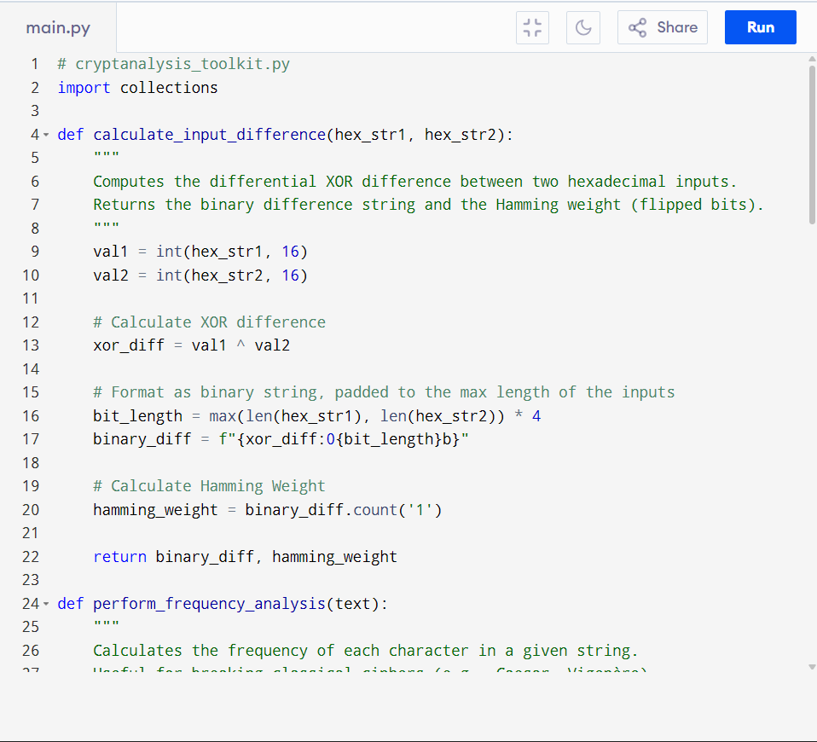
Figure 38 cryptanalysis toolkit
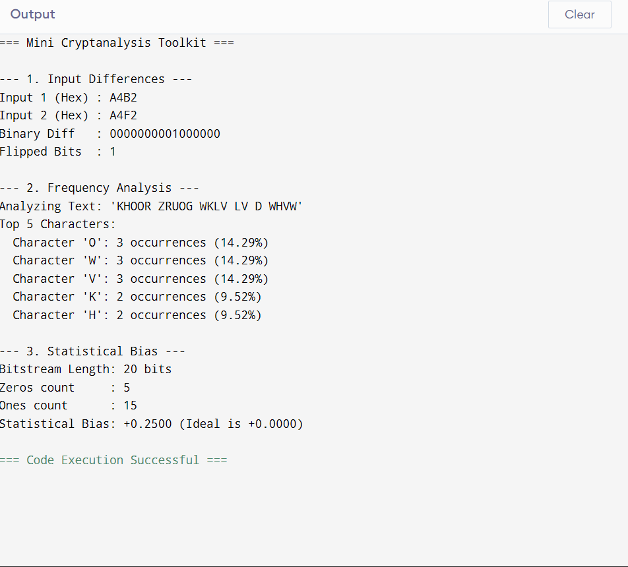
Figure 39 cryptanalysis toolkit
  - Challenge Task
BLOCK CYPHER SECURITY ANALYSER
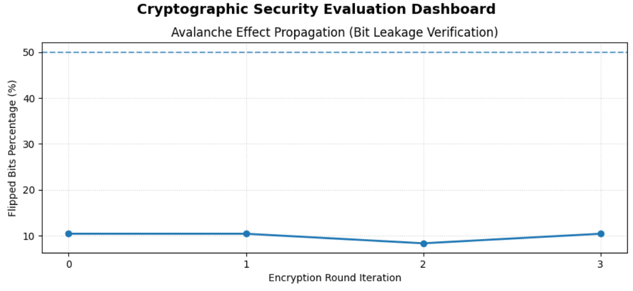
Figure 40 Frequency Distribution
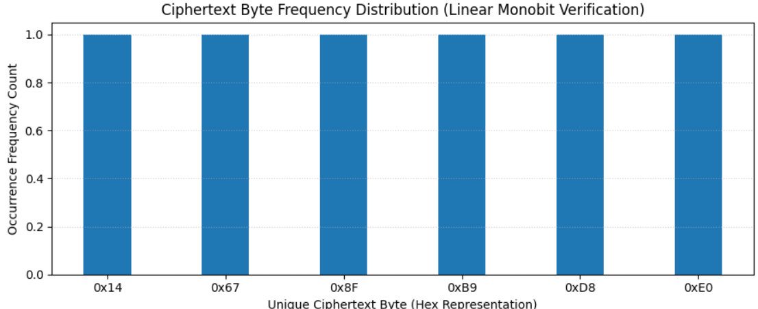
Figure 41 Statistical Reporting
Student Reflection
I transitioned to practical application by scripting a Python Block Cipher Security Analyzer. I successfully built automated tools to measure the Avalanche Effect, test input differences, and generate statistical reports.
Creative Task
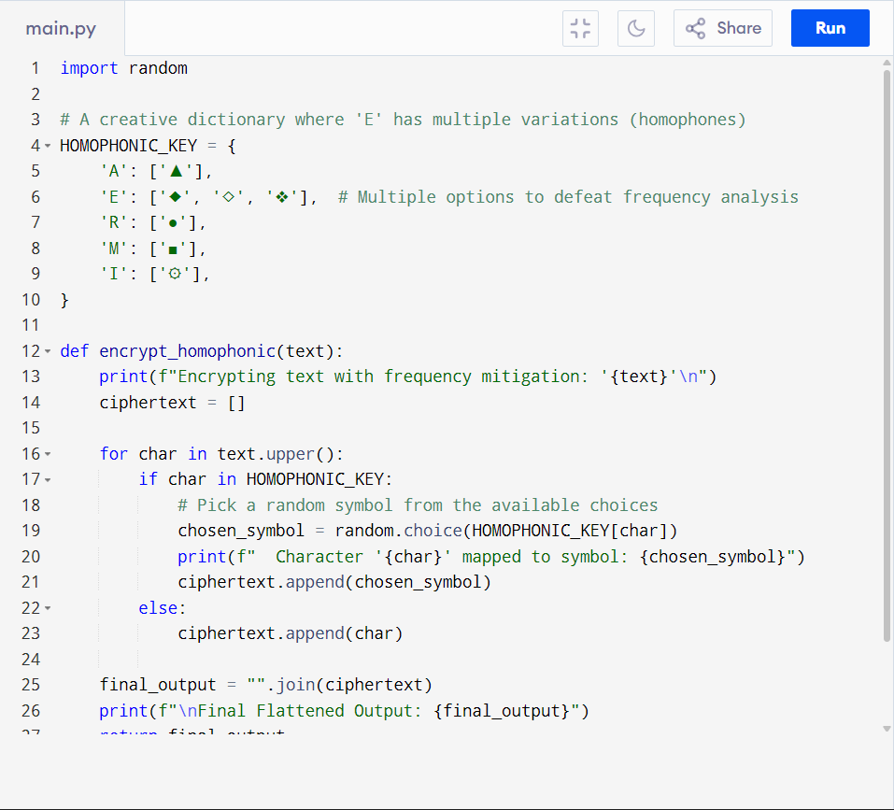
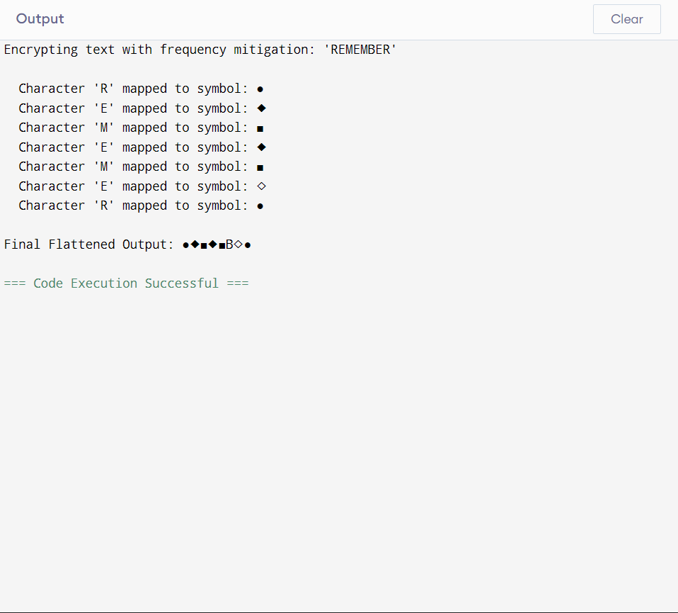

Week 8

Class activity 1
PKI Component Roles
- a) Certificate Authority (CA) The CA is the ultimate root of trust in the PKI. Its primary role is to issue, manage, and revoke digital certificates. When a certificate is generated, the CA uses its own highly protected private key to digitally sign it, effectively vouching for the identity of the certificate holder.
- b) Registration Authority (RA) The RA acts as the identity verifier. Its role is to accept certificate requests and verify the identity of the entity making the request before passing it along to the CA. The RA does not issue certificates itself; it strictly handles the administrative vetting process to ensure the requester is who they claim to be.
- c) Digital Certificate A digital certificate is an electronic document whose role is to cryptographically bind a public key to a specific entity's identity (like a person, organization, or server). It contains the public key, information about the owner, expiration dates, and the digital signature of the CA that issued it, acting much like a digital passport.
- d) End User The end user (which can be a human, a web server, a device, or a software application) is the entity that requests, receives, and utilizes the digital certificate. They use it to establish secure, encrypted communications (like HTTPS), digitally sign code or documents, or authenticate themselves to other systems.
- e) Certificate Repository The repository is a publicly accessible database or directory whose role is to store issued certificates and Certificate Revocation Lists (CRLs). It allows systems and applications to quickly look up a public key or check whether a specific certificate is still valid or if it has been revoked by the CA prior to its expiration date.

Class activity 2
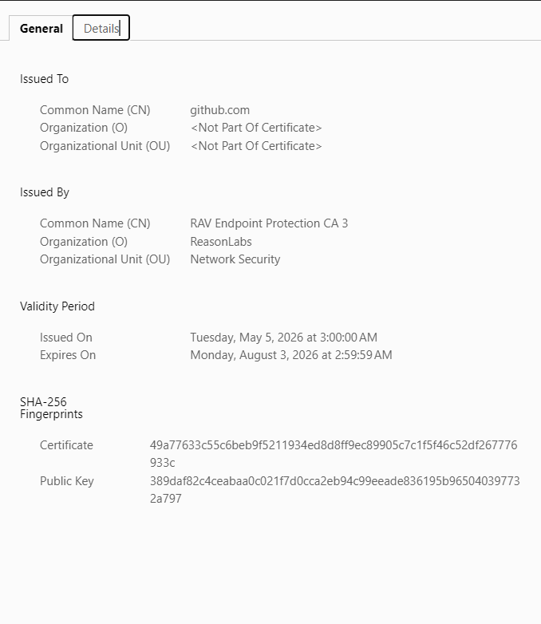
Figure 42 git hub certificate

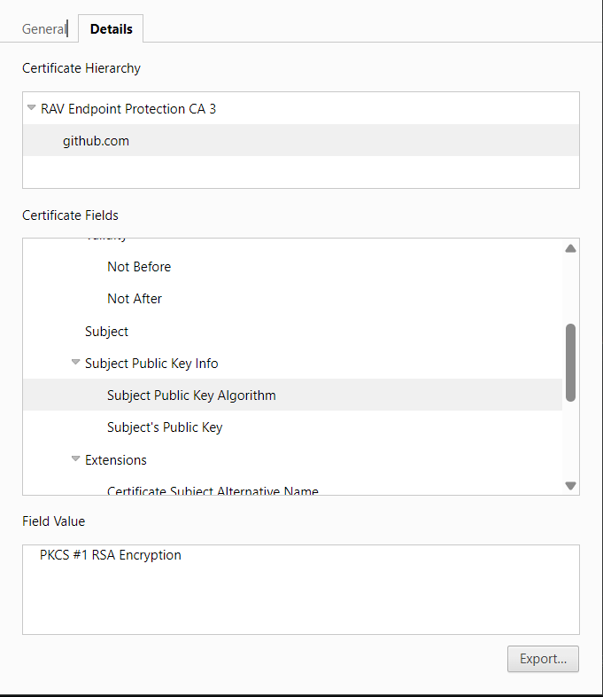
Figure 43 github key encryption

An analysis of the digital certificate for the target website, github.com, conducted on June 28, 2026, reveals that the certificate is specifically bound to the subject name github.com. The certificate was issued by RAV Endpoint Protection CA 3, which is operated by Reason Labs, and remains valid until its expiration date on August 3, 2026, at 2:59:59 AM. For its cryptographic framework, the certificate utilizes PKCS #1 RSA Encryption to facilitate secure key exchanges. Notably, the presence of Reason Labs as the issuing Certificate Authority indicates that local endpoint security software is actively performing SSL inspection decrypting, inspecting, and re-signing HTTPS traffic on the fly rather than routing the certificate chain directly to a standard public commercial Certificate Authority.

Practical Task
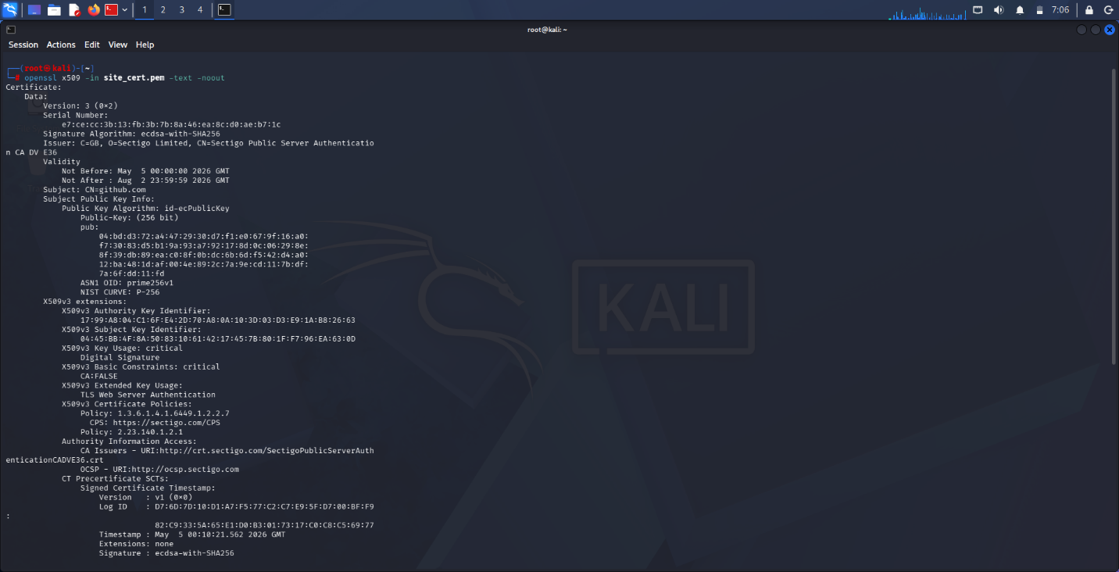
Figure 44 OpenSSL Certificate Inspection
Issuer: C=GB, O=Sectigo Limited, CN=Sectigo Public Server Authentication CA DV E36
Validity
Not Before: May 5 00:00:00 2026 GMT
Not After : Aug 2 23:59:59 2026 GMT
Subject: CN=github.com
Subject Public Key Info:
Public Key Algorithm: id-ecPublicKey
Public-Key: (256 bit)

Assignment
Incident Report: The 2024 DigiCert Mass Revocation
1. Organization Involved The incident centrally involved DigiCert, one of the world's largest and most widely trusted commercial Certificate Authorities (CAs). DigiCert provides the public key infrastructure (PKI) and identity validation solutions that secure millions of web servers, enterprise networks, and critical applications globally.
2. Cause of the Incident In late July 2024, DigiCert disclosed a significant compliance breach stemming from a legacy software bug in its Domain Control Verification (DCV) system. According to the strict Baseline Requirements set by the CA/Browser (CA/B) Forum, when a CA validates domain ownership using a DNS CNAME record, the record must contain a specific, randomized value and be prefixed with an underscore (e.g., _auth.example.com).
During an internal audit, DigiCert discovered that for approximately five years (dating back to August 2019), their automated validation platform had failed to verify the presence of this mandatory underscore prefix. While there was no evidence that this flaw was actively exploited by malicious actors to obtain fraudulent certificates, the failure to perform the exact technical validation meant that DigiCert was non-compliant with industry standards. In the rigidly governed PKI ecosystem, a certificate issued through a flawed validation process is considered technically mis-issued and untrustworthy, regardless of malicious intent.
3. Impact on Users The fallout from this bug was immediate and chaotic due to the CA/B Forum's mandate that all mis-issued certificates must be revoked within 24 hours of discovery.
- Mass Revocation: DigiCert was forced to announce the urgent, mandatory revocation of over 83,000 active TLS/SSL certificates globally.
- Operational Crisis for Enterprises: Network administrators and IT teams were given less than a day to generate new Certificate Signing Requests (CSRs), undergo re-validation, and deploy new certificates across complex infrastructures.
- Threats to Critical Infrastructure: The 24-hour window proved operationally impossible for many large-scale enterprises, including major telecommunications providers (like Vodafone) and healthcare payment processors (such as Alegeus Technologies). The abrupt revocation threatened to cause massive outages, effectively severing secure connections for hospitals, financial transactions, and public services.
- Emergency Legal Action: The threat of immediate, catastrophic downtime was so severe that some affected customers sued DigiCert. Several organizations obtained emergency temporary restraining orders from federal courts to legally block the CA from revoking their certificates until a safe migration could be completed.
4. Corrective Actions Taken DigiCert’s response required navigating both technical remediation and complex industry policy:
- System Patching: DigiCert immediately patched the logic flaw in their DCV platform to ensure all future CNAME validations strictly enforce the underscore prefix requirement.
- Rapid Reissuance: The company mobilized emergency support teams to assist affected customers in rapidly reissuing and deploying replacement certificates free of charge.
- Regulatory Exceptions: Facing lawsuits and the reality of critical infrastructure collapse, DigiCert formally petitioned the CA/B Forum to delay the 24-hour revocation deadline. They secured short-term extensions for specific critical infrastructure operators, granting them a brief grace period to safely complete the migration.
- Code Transparency: To rebuild trust within the cybersecurity community, DigiCert committed to open-sourcing the specific code block used for their domain validation checks, allowing independent security researchers to audit the logic for any other latent bugs.
5. Lessons Learned for PKI Security This incident served as a critical stress test for modern PKI governance, yielding several key takeaways for network administration and cryptographic security:
- The Absolute Necessity of Crypto-Agility: The incident proved that manual certificate lifecycle management is a massive organizational risk. Enterprises must implement automated, crypto-agile systems (utilizing protocols like ACME) capable of rotating thousands of certificates across decentralized endpoints within hours, without requiring human intervention.
- Friction Between Compliance and Continuity: A major debate emerged regarding the rigidity of CA/B Forum rules. While immediate revocation limits the exposure window of compromised cryptographic keys, applying a blanket 24-hour "kill switch" for purely administrative bugs can inadvertently cause catastrophic denial-of-service (DoS) conditions for the public. The ecosystem requires a more nuanced, risk-based revocation framework.
- The Hidden Risks of Technical Debt: The bug existed in DigiCert’s code for five years entirely undetected. This highlights that even highly audited, top-tier cryptographic authorities are vulnerable to underlying logic errors. Continuous, automated regression testing and external code auditing are imperative for entities acting as the ultimate root of trust for the internet.

Class exercise one
a) Public Key Think of a public key like an open padlock or your email address. It’s a cryptographic key that you can (and should) share freely with anyone in the world. When someone wants to send you a secure message, they use your public key to lock up (encrypt) the data. Because it’s just the "padlock," it can't be used to unlock the message once it's sealed.
b) Private Key If the public key is the padlock, the private key is the actual physical key you keep on your keychain. This is a closely guarded secret that you never share with anyone. It is mathematically linked to your public key, but it works in reverse: it is the only thing in the universe that can unlock (decrypt) the data that was encrypted by your public key.
c) Symmetric Encryption This is the old-school way of encrypting things. Symmetric encryption uses the exact same secret key to both lock and unlock the data. It’s incredibly fast and efficient for processing large amounts of data, but it has a major flaw: if two people want to communicate securely over the internet, how do they safely share that single secret key in the first place without someone intercepting it?
d) Asymmetric Encryption Also known as public-key cryptography, this solves the key-sharing problem mentioned above. It uses a paired system—one key to encrypt (the public key) and a different, mathematically related key to decrypt (the private key). While it solves the problem of securely communicating with strangers over an untrusted network, it requires a lot more processing power, which is why it’s usually just used to securely swap a symmetric key to handle the rest of the session.

Class Exercise two
Why Computationally Hard Problems Matter The entire foundation of modern cryptographic systems relies on a concept called "trapdoor functions." A trapdoor function is a mathematical operation that is very easy and fast for a computer to calculate in one direction, but virtually impossible to reverse-engineer without knowing a special piece of secret information (the private key).
We need computationally hard problems because we assume attackers have access to massive amounts of computing power. If the math securing our data was easy to reverse, an attacker could just brute-force the algorithm and find the original plaintext. By basing encryption on mathematical problems that would take the world's most powerful supercomputers thousands of years to solve, we guarantee that the data remains secure in a practical sense.
Three Examples of Computationally Hard Problems:
- Integer Factorization (Used in RSA): It is extremely easy for a computer to take two massive prime numbers and multiply them together to get a gigantic result. However, if you only give the computer that final gigantic number, figuring out which two prime numbers were multiplied to create it is a massively complex, computationally hard problem.
- The Discrete Logarithm Problem (Used in Diffie-Hellman): This involves modular arithmetic (often called "clock math"). It’s very easy to take a base number, raise it to a certain power, and divide it by a prime number to find the remainder. But if you only know the base, the prime, and the final remainder, figuring out what the original exponent was is incredibly difficult.
- Elliptic Curve Discrete Logarithm Problem (Used in ECDSA/ECC): This is a more advanced take on the discrete logarithm, using the algebraic structure of elliptic curves over finite fields. Instead of multiplying numbers, it involves finding a point on a curve and "adding" it to itself a specific number of times. Reversing that process to find out exactly how many times the point was added is so mathematically dense that it allows us to use much shorter encryption keys while providing the same level of security as older, bulkier algorithms.

Practical Task

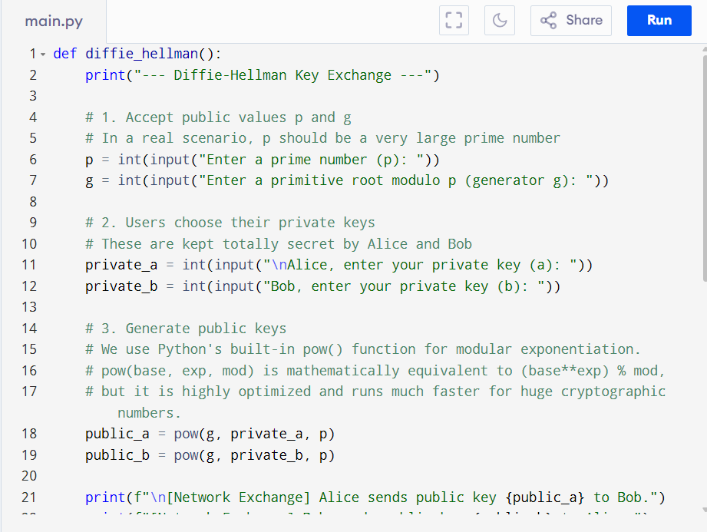
Figure 45 diffie hellman source code
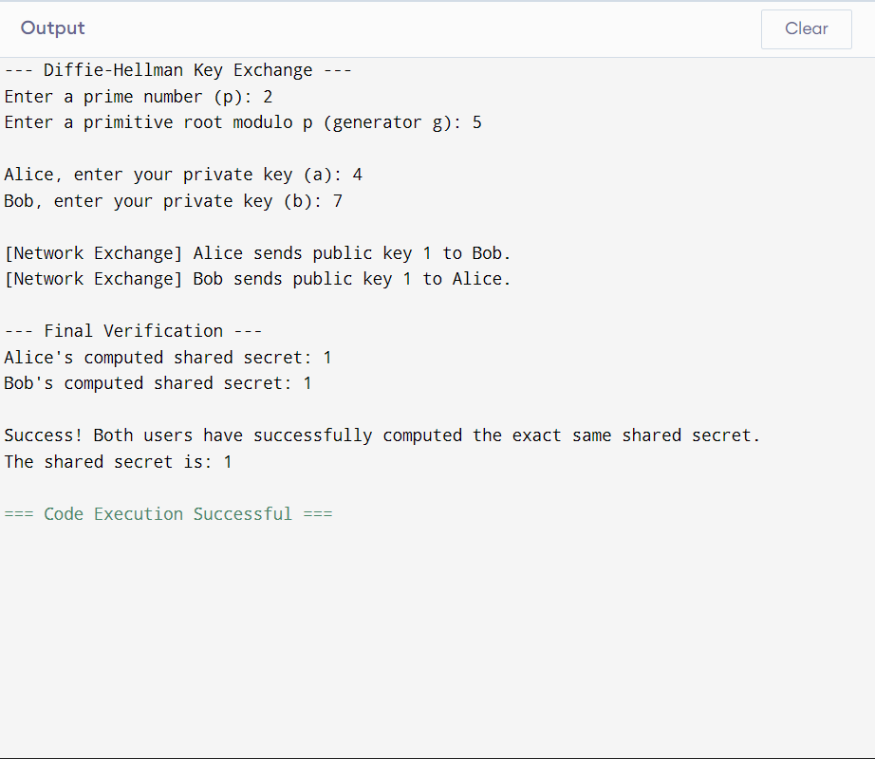
Figure 46 diffie hellman output

Assignment
The Diffie-Hellman (DH) key exchange, introduced in 1976 by Whitfield Diffie and Martin Hellman, is a fundamental cryptographic protocol that enables two parties to jointly establish a shared secret key over an insecure communications channel. This shared secret can subsequently be utilized to encrypt data using a symmetric-key cipher. It represents the first published practical method for establishing a shared secret over an unprotected network without requiring the prior physical or secure exchange of keys.
2. Operational Mechanics of the Protocol
The Diffie-Hellman protocol relies on the mathematical properties of modular arithmetic. The exchange proceeds through the following computational steps:
Parameter Agreement: The communicating parties (conventionally designated as Alice and Bob) publicly agree on two parameters: a large prime number (p) and a base, also known as a primitive root modulo p (g). These parameters are transmitted in plaintext and are visible to any network observer.
Private Key Generation: Each party generates a random integer that is strictly retained as private. Alice selects private key a, and Bob selects private key b.
Public Key Computation:
Alice computes her public key (A) using the formula: A = g^a \pmod p
Bob computes his public key (B) using the formula: B = g^b \pmod p
Public Key Exchange: Alice and Bob exchange their computed public keys (A and B) over the insecure channel.
Shared Secret Derivation:
Alice computes the shared secret (S) by raising Bob's public key to her private key: S = B^a \pmod p
Bob computes the identical shared secret (S) by raising Alice's public key to his private key: S = A^b \pmod p
Due to the commutative properties of modular exponentiation, both calculations yield the exact same integer: (g^b)^a \pmod p = (g^a)^b \pmod p. This derived integer serves as the symmetric cryptographic key for the session.
3. The Discrete Logarithm Problem
The security architecture of the Diffie-Hellman exchange is predicated on the computational intractability of the Discrete Logarithm Problem (DLP). While it is computationally efficient to calculate the public keys via modular exponentiation, executing the inverse operation is exceedingly difficult.
If an adversary intercepts the public parameters (p, g, A, and B), they must solve the equation A = g^a \pmod p to determine the private key a. For sufficiently large values of p (e.g., 2048-bit integers), calculating the discrete logarithm requires an infeasible amount of computational resources and time using classical computing architecture. This asymmetry in computational difficulty provides the cryptographic foundation of the protocol.
4. Applications in TLS/SSL
In contemporary network security, Diffie-Hellman is a critical component of Transport Layer Security (TLS) and Secure Sockets Layer (SSL) protocols, which protect data traversing the web (HTTPS). Its most vital implementation is Ephemeral Diffie-Hellman (DHE) and Elliptic Curve Diffie-Hellman Ephemeral (ECDHE).
Perfect Forward Secrecy (PFS): Traditional key exchanges often utilized a server's static RSA private key to encrypt the session key. If the server's private key was compromised in the future, an adversary could retroactively decrypt all historical captured traffic. DHE and ECDHE generate unique, temporary parameters for every individual session. Consequently, the compromise of a server's long-term key does not compromise past session keys, ensuring Perfect Forward Secrecy.
Efficiency and Elliptic Curves: ECDHE utilizes the algebraic structure of elliptic curves over finite fields, offering equivalent cryptographic strength to standard Diffie-Hellman but with significantly smaller key sizes. This reduction decreases processing overhead and latency during the TLS handshake.
5. Security Challenges and Solutions
Despite its mathematical robustness, the implementation of Diffie-Hellman faces distinct security vulnerabilities:
Man-in-the-Middle (MitM) Attacks: The standard DH protocol does not inherently provide endpoint authentication. An active adversary could intercept communications, establishing separate DH exchanges with both parties, thereby decrypting and manipulating the data in transit.
Solution: Diffie-Hellman must be paired with digital signatures (e.g., RSA or ECDSA algorithms) backed by a Public Key Infrastructure (PKI). Parties verify the authenticity of the public parameters via digital certificates before finalizing the exchange.
The Logjam Attack: Researchers have demonstrated that if servers utilize weak or standardized, pre-computed prime numbers (e.g., 512-bit or 1024-bit primes), well-resourced adversaries can pre-compute data to rapidly break individual key exchanges.
Solution: Industry standards now mandate the use of minimum 2048-bit discrete logarithm parameters or the adoption of Elliptic Curve Cryptography (ECC), which is immune to the specific number field sieve algorithms used in Logjam.
The Quantum Computing Threat: The advent of cryptographically relevant quantum computers executing Shor's algorithm will render the Discrete Logarithm Problem easily solvable, effectively neutralizing standard Diffie-Hellman security protocols.
Solution: Cryptographic authorities are actively standardizing Post-Quantum Cryptography (PQC), developing algorithms based on lattice structures and hash-based frameworks that resist quantum decryption methodologies.

Student reflection
Completing these cryptography tasks was eye-opening. Analyzing live certificates, using OpenSSL, and coding the Diffie-Hellman exchange in Python brought the theoretical math to life. It perfectly demonstrated how public key infrastructure actually secures modern networks. This logbook update really solidifies my foundational security skills.

WEEK 9

Programming task
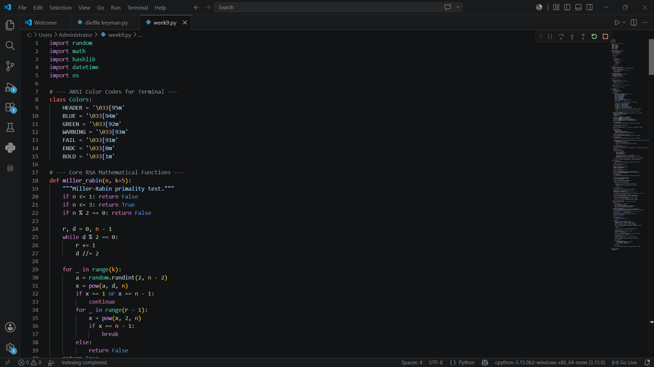
Figure 47 python source code
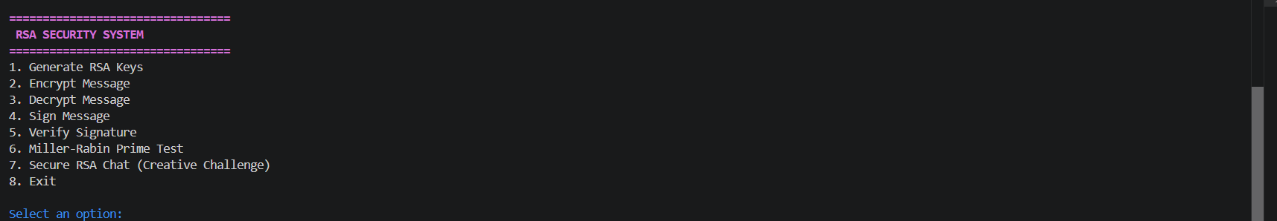
Figure 48 rsa security system
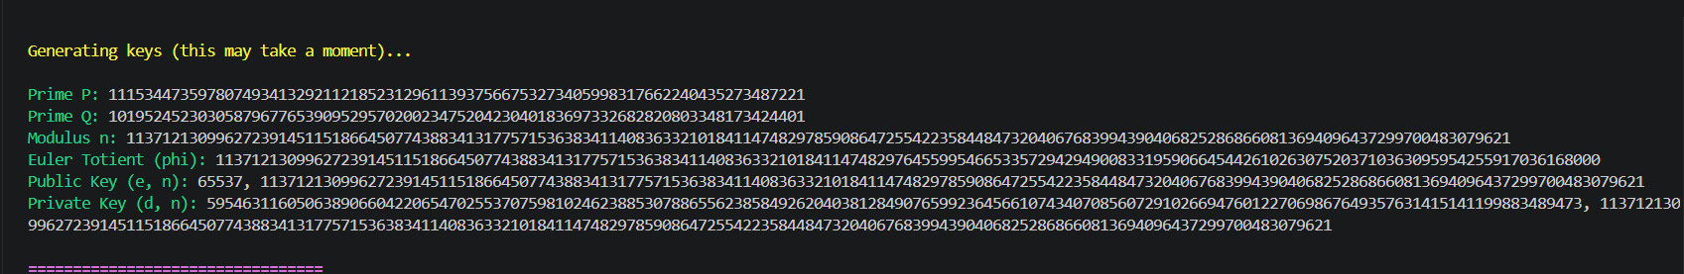
Figure 49 generation of rsa keys
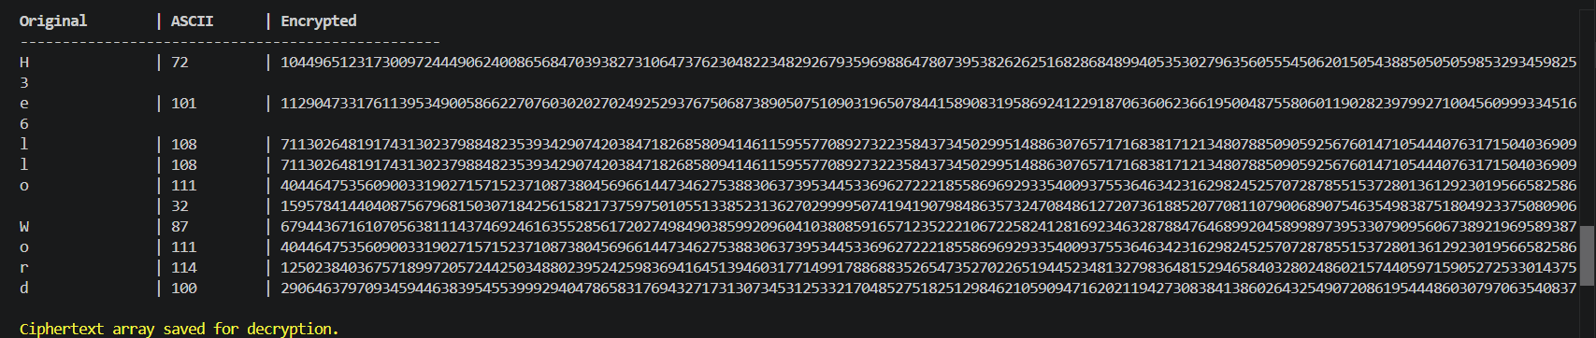
Figure 50 encryption of messages
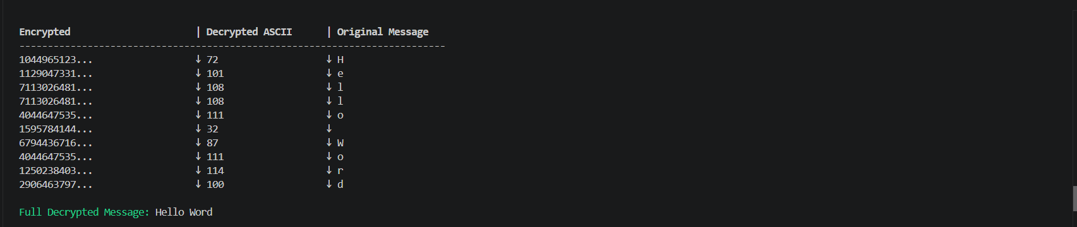
Figure 51 decryption of messages
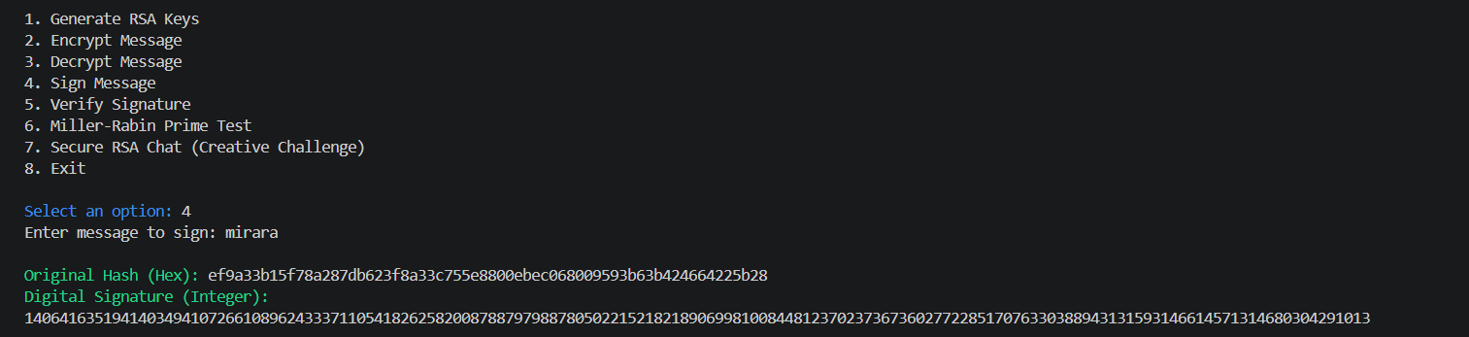
Figure 52 message signature
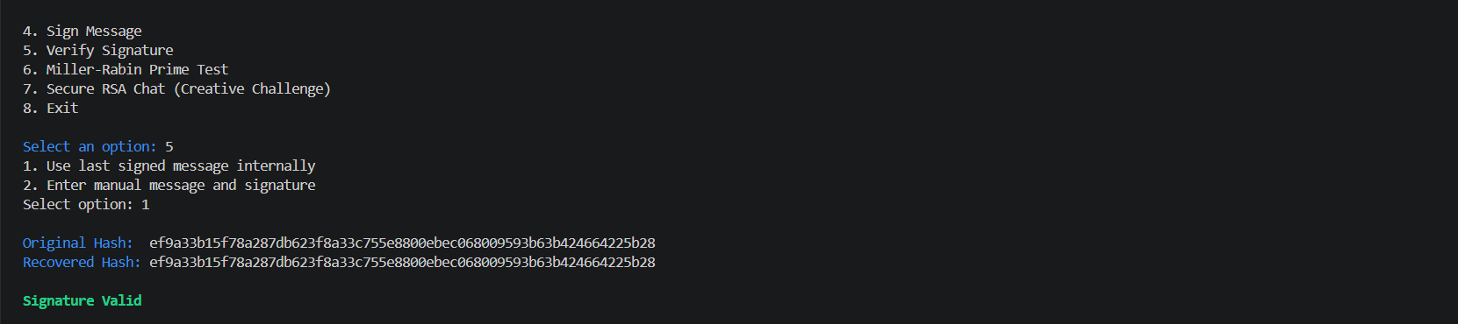
Figure 53 verification of signatures
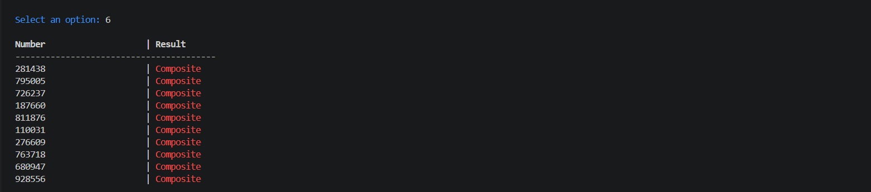
Figure 54 miller rabin prime test

Creative challenge

Figure 55 python source code
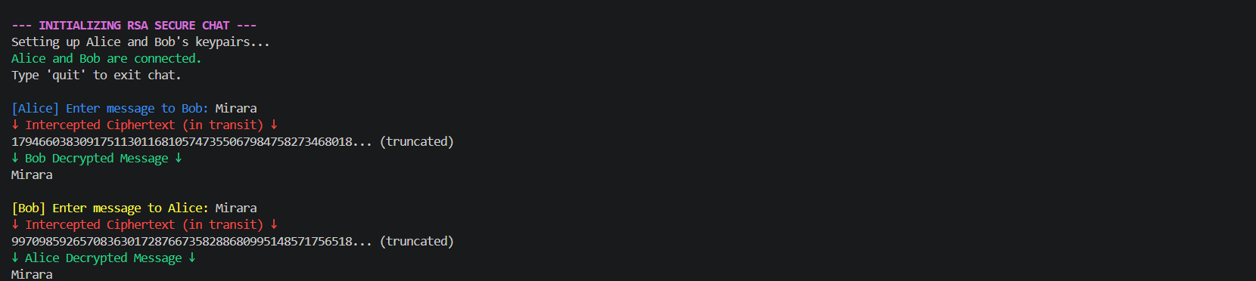
Figure 56 message exchange between bob and alice

Research Report: Real-World Application of the RSA Cryptosystem
Topic: Securing HTTPS Websites via SSL/TLS Handshakes
Introduction The RSA (Rivest–Shamir–Adleman) algorithm is a cornerstone of modern digital security and a fundamental topic in advanced cryptography. While encrypting massive databases or live video streams directly with RSA is computationally prohibitive due to the complex modular exponentiation involved, the algorithm is perfectly suited for a different, critical task: securely establishing trust and exchanging keys over an insecure network. The most ubiquitous real-world application of RSA is within the SSL/TLS (Secure Sockets Layer / Transport Layer Security) protocols, which form the "S" in HTTPS, protecting web applications, banking portals, and administrative dashboards from interception.
The Threat Landscape: Why RSA is Necessary When a client (such as a web browser) communicates with a remote server, the data packets traverse multiple, potentially untrusted routers and nodes. Without encryption, network vulnerability scanners or malicious actors using packet sniffers could easily intercept plaintext data, including passwords, session tokens, or sensitive database queries.
To prevent Man-in-the-Middle (MitM) attacks, the client and server must encrypt their traffic. However, they face a classic cryptographic paradox: how can two parties agree on a secret encryption key over a network that is already being monitored? RSA solves this through asymmetric key exchange and digital signatures.
The RSA Mechanism in the SSL/TLS Handshake When a user navigates to an HTTPS website, a process known as the TLS handshake occurs in the background. RSA historically plays two pivotal roles in this sequence:
- Server Authentication (Digital Signatures): Before sending any sensitive data, the client must verify that the server is legitimate. The server presents an SSL/TLS Certificate, which contains the server's RSA Public Key. This certificate is digitally signed by a trusted third party known as a Certificate Authority (CA). The CA hashes the server's certificate and encrypts that hash with its own RSA Private Key. The client's browser, which comes pre-loaded with the CA's Public Key, decrypts the signature. If the decrypted hash matches the client's own computation of the certificate's hash, trust is established. This mathematically guarantees the server's identity.
- Secure Key Exchange (Key Encapsulation): Once trust is verified, the client and server need to agree on a fast, symmetric key (like AES) for the actual data transmission.
  - The client generates a random string of data called a "pre-master secret."
  - The client encrypts this pre-master secret using the server’s RSA Public Key (extracted from the verified certificate).
  - The encrypted secret is sent across the open network. Even if intercepted, it is mathematically infeasible to decrypt without the corresponding private key.
  - The server receives the ciphertext and decrypts it using its securely guarded RSA Private Key.
  - Both parties now independently use this pre-master secret to generate the same symmetric session keys.
The Shift to Hybrid Systems It is important to note that RSA is rarely used in isolation. Web developers and network administrators deploy hybrid cryptosystems. RSA handles the heavy lifting of authentication and the initial secure key exchange, while symmetric algorithms (which are significantly less CPU-intensive) handle the bulk encryption of the HTML, CSS, PHP scripts, and database responses that make up the web application.
Furthermore, while modern TLS 1.3 standards are shifting toward Elliptic-Curve Diffie-Hellman (ECDHE) for the key exchange portion to provide "forward secrecy," RSA remains the undisputed industry standard for the digital certificate signatures that authenticate nearly every secure web server on the internet today.
Conclusion The RSA cryptosystem provides the initial layer of trust that makes the modern web possible. By allowing systems to authenticate identities and securely distribute symmetric keys over hostile networks, RSA ensures that web applications remain secure against interception, protecting both user privacy and the integrity of data in transit.

Creative task
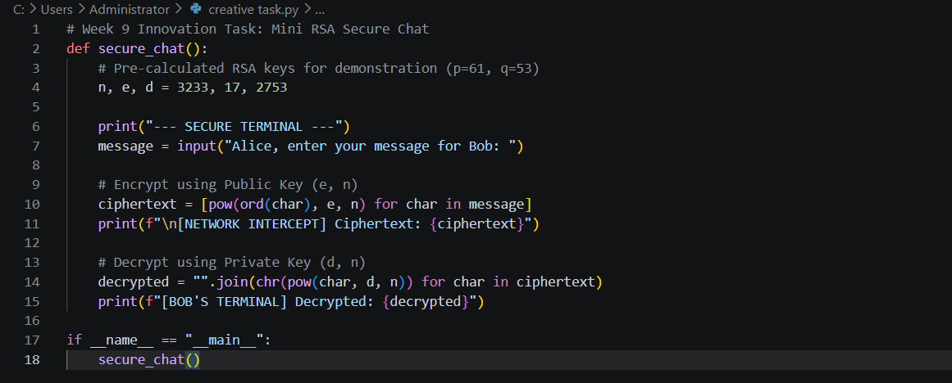
Figure 57 creative task source code
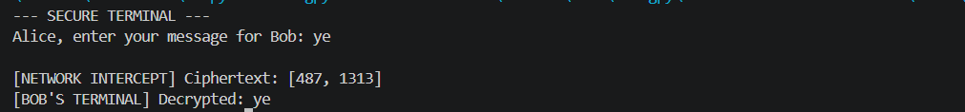
Figure 58 creative task output

Student reflection
I practically implemented the RSA cryptosystem and Miller-Rabin primality testing using Python. Building a secure chat application for the creative challenge deepened my understanding of asymmetric key exchange, digital signatures, and how cryptographic theory directly secures real-world digital communications.

